DEVELOPMENT OF CUSTOM ARCH-BASED OPERATING SYSTEM
WITH A COMPARATIVE STUDY ON
WINDOWS AND MACOS

A Thesis Project
Presented to the
College of Information Technology Education
Arellano University – Jose Abad Santos Campus

In Partial Fulfillment of the Requirement for the
Bachelor of Science in Computer Science

By

ARIATE, JOMEL JAY H.
SORITA, PRINCE F.
RUPIDO, GERALD Z.

DR. LEONARD L. ALEJANDRO
Technical Adviser

March 2026

DEDICATION

This thesis is humbly dedicated to the Almighty God, whose divine guidance, infinite wisdom, and abundant blessings bestowed upon us the strength, perseverance, and resilience necessary to accomplish this academic endeavor.
We likewise dedicate this work to our beloved families, whose unwavering love, patience, and steadfast support have sustained us throughout our academic journey. Their sacrifices, encouragement, and enduring belief in our capabilities have served as a profound source of inspiration and motivation.
Our deepest gratitude is also extended to our esteemed professors, mentors, and adviser, particularly Dr. Leonard L. Alejandro, whose invaluable guidance, scholarly expertise, and constructive insights significantly enriched the quality and completion of this research.
Furthermore, this study is dedicated to Arellano University – Jose Abad Santos Campus and to future researchers in the field. It is our earnest hope that this work, especially the proposed Grades Management System with Data Analytics, will contribute meaningfully to the enhancement of academic processes and serve as a valuable reference for subsequent studies and innovations in the field of education.

EXECUTIVE SUMMARY

Title: DEVELOPMENT OF CUSTOM ARCH-BASED OPERATING WITH A COMPARATIVE STUDY ON WINDOWS AND MACOS

Developers: ARIATE, JOMEL JAY H.
SORITA, PRINCE F.
RUPIDO, GERALD Z.

Class Adviser: Dr. Leonard L. Alejandro
Technical Adviser: Dr. Leonard L. Alejandro

Copyright Year: 2026

Summary: This thesis centers on the development of a custom Arch-based operating system, herein referred to as Bridge OS, designed to demonstrate the flexibility and extensive customization capabilities inherent in Linux-based systems. The system was developed using Arch Linux as its foundational framework and incorporates the KDE Plasma desktop environment to deliver a modern and user-friendly interface. Furthermore, Bridge OS integrates customized visual elements, including a unique system background, proprietary logo, and a built-in web browser, thereby establishing a distinct and personalized operating system environment.
The primary objective of this study is to design and implement a functional operating system while conducting a comparative analysis with widely used commercial platforms, particularly Microsoft Windows and Apple macOS. The comparison focuses on key dimensions such as system performance, usability, interface design, and overall user experience.
Through a systematic development and testing process, the researchers evaluated the extent to which an Arch-based system can serve as a viable alternative for users who prioritize customization, efficiency, and the flexibility afforded by open-source technologies. The findings underscore the strengths of Bridge OS in terms of adaptability and lightweight performance, while also providing critical insights into the distinctions between Linux-based systems and proprietary operating systems.
Overall, this study highlights the potential of custom Linux distributions to deliver efficient, scalable, and highly customizable computing environments. Moreover, it contributes to a deeper understanding of operating system design principles, development processes, and functional optimization within contemporary computing contexts.

TABLE OF CONTENTS
Pages
TITLE PAGE i
APPROVAL SHEET ii
DEDICATION iii
EXECUTIVE SUMMARY iv
TABLE OF CONTENTS v

CHAPTER 1: INTRODUCTION 1
1.1 Introduction 1
1.2 Purpose and Focus 2
1.3 Research Questions 2

CHAPTER 2: REVIEW OF RELATED LITERATURES/SYSTEMS AND STUDIES 2
2.1 Local Literatures 2
2.2 Foreign Literatures 3
2.3 Local Studies 3
2.4 Foreign Studies 4

CHAPTER 3: METHODOLOGY 5
3.1 Requirements Analysis 5
3.1.1 Software Development Life Cycle 5
3.1.2 Conceptual Diagram 5
3.1.3 Flow of Existing System 6
3.1.3.1 Flow Chart of the Existing System 6
3.1.3.2 Data Flow Diagram of the Existing System 7
3.1.3.3 Level 1 Data Flow Diagram of the Existing System 7
3.1.4. Flow of Proposed System 8
3.1.4.1 Flow Diagram of the Proposed System 8
3.1.4.2 Level 1 Flow of Proposed System 8
3.2 Requirements Documentation 9
3.2.1 Research Methods 9
3.2.2 Analysis Methods 9
3.2.3 Scope 9
3.3 Technical Background 10
3.3.1 Product Description 10
3.3.2 Economic Use of the Product 10
3.3.3 User Requirements 10
3.3.4 System Requirements 10
3.3.5 Setting and Participants 10
3.4 Development and Testing 10
3.5 Description of the Prototype 11
3.6 Implementation Plan 13
3.7 Implementation Results 13

CHAPTER 4: SUMMARY, CONCLUSION AND RECOMMENDATIONS 13
4.1.A Results 13
4.1.B Testing Project Results 13
4.1.C Final Evaluation Outcome (User Review) 14
4.2 Conclusions 15
4.4 Recommendation 15

CHAPTER 5: ACKNOWLEDGEMENT 15
6. REFERENCES 15
LIST OF APPENDICES 17
A. Certificate of Implementation 18
B. Sample Input/Output/Report 19
C. Presentation of Findings 22
D. Evaluation Tool/Test Documents 24
E. Certificate of Initial and Final Testing 30
F. Gantt Chart of Development Schedule 32
G. User's Manual 33
H. Documentation Photos 43

LIST OF TABLES
Table 1. Technical Comparison 13
Table 2. Composite Mean 14

LIST OF FIGURES
Figure 1. SDLC - Agile Model 5
Figure 2. Input-Process-Output-Benefits (IPOB) Diagram 6
Figure 3. Flowchart of Windows and MacOS 6
Figure 4. DFD of Windows and MacOS (Level 0) 7
Figure 5. DFD of Windows and MacOS (Level 1) 7
Figure 6. Data Flow Diagram of the Custom Arch OS (Level 0) 8
Figure 7. Data Flow Diagram of the Custom Arch OS (Level 1) 8
Figure 8. Bootloader (GRUB) 11
Figure 9. Display/Login Manager (ly) 11
Figure 10. Desktop Environment (KDE) 11
Figure 11. Application Search Engine 11
Figure 12. File Manager 12
Figure 13. Text Editor 12
Figure 14. System Settings 12
Figure 15. Terminal 12
Figure 16. Bridge Browser 12
Figure 17. System Information (FastFetch) 13
Figure 18. Resource Usage (System Monitor) 13

Development of Custom Arch-Based Operating System with a Comparative Study on Windows and MacOS
Jomel Jay H. Ariate
Arellano University
jomel.ariate134@gmail.com
Prince F. Sorita
Arellano University
princesorita0813@gmail.com
Gerald Z. Rupido
Arellano University
geraldrupido05@gmail.com

OVERVIEW
This study presents the design and development of a customized Arch-based Linux operating system intended as an alternative to Microsoft Windows. The proposed system adopts a minimalistic approach, incorporating only essential drivers and core packages, and utilizes the KDE Plasma desktop environment to provide a modern graphical interface. Its primary objective is to deliver a lightweight, secure, and highly customizable platform that enables users to tailor the system according to their specific requirements [1].
The research describes the system’s architecture, data design, user interface design, and reporting functionalities. Furthermore, it reviews related literature on operating system customization, Linux-based security mechanisms, and usability considerations, emphasizing their relevance to the present study [2], [3].
By addressing challenges such as high resource consumption, limited configurability, and reliance on proprietary software, the proposed operating system aims to provide a practical and adaptable solution for both academic and personal use [4].
Categories and Subject Descriptors
Software and its engineering → Operating systems → System software customization; Security and Privacy → Operating systems security; Computer systems organization → Architectures → Open-source platforms
General Terms
Design, Performance, Security, Reliability, Experimentation, Usability, Customization
Keywords
Linux, Arch Linux, Customized Operating System, KDE Plasma, Pacman, Open-Source Software, Windows Alternative, Minimal OS, System Architecture, User Interface Design

CHAPTER 1: INTRODUCTION
The limitations of Microsoft Windows—including high resource consumption, susceptibility to security threats, and the presence of bundled bloatware—serve as the primary motivation for this project [5]. These issues are particularly significant for professionals in fields such as software development, where system efficiency and security are critical. In contrast, macOS, while offering greater stability, is restricted to Apple devices, thereby limiting accessibility and compatibility [6].
To address these challenges, this project proposes the development of a Linux-based operating system that enables users to install only the necessary components, thereby improving performance and enhancing system security while minimizing unnecessary overhead [7]. The identified problems—limited customizability, performance inefficiencies, and security vulnerabilities—are especially evident among users who depend on their systems for specialized tasks.
This research primarily targets IT professionals, developers, and researchers who require a customizable, efficient, and secure computing environment. The proposed system aims to address these concerns by offering a Linux-based solution that balances performance, security, and adaptability, while remaining more accessible than proprietary alternatives.
1.1 Introduction
Operating systems (OS) are fundamental software that enable computers to function by managing hardware resources and providing essential services to applications. Widely used operating systems such as Windows and macOS exhibit several limitations that reduce their suitability for users with specialized requirements. Windows, for instance, is resource-intensive, vulnerable to security threats, and often includes unnecessary pre-installed applications that may degrade performance [5]. macOS, while generally more stable and efficient, is limited to Apple hardware, thereby restricting compatibility and accessibility [6]. These limitations underscore the need for a more flexible and efficient alternative, particularly for users seeking greater control over system performance, security, and functionality.
This project proposes the development of a Linux-based operating system as a viable alternative to Windows and macOS. As an open-source platform, Linux offers extensive customization capabilities, allowing users to configure their computing environment according to specific requirements. This flexibility enables the removal of unnecessary components, thereby improving system performance and reducing overhead [7]. Unlike proprietary operating systems that are distributed with predefined configurations and limited customization options, Linux allows users to tailor both the user interface and core system processes. Such adaptability not only enhances efficiency but also strengthens security by minimizing potential vulnerabilities [8].
By developing a Linux-based operating system, this study aims to provide a cost-effective and customizable alternative to proprietary platforms. The proposed system is intended to serve a diverse range of users—from general consumers to professionals engaged in specialized tasks such as software development and data analysis. Through enhanced control over system components and performance, users can optimize hardware utilization, reduce unnecessary resource consumption, and improve overall computing efficiency [9].

1.2 Purpose and Focus
The primary purpose of this project is to develop a customizable Linux-based operating system that serves as an alternative to Windows and macOS. The intended users include individuals and organizations seeking greater control over system performance, security, and functionality. This project aims to address the limitations of proprietary operating systems by providing an efficient, flexible, and open-source solution.

Research Questions

General Objective
To design and develop a Linux-based OS capable of running on low-end devices that serve as a functional, secure, and cost-effective alternative to Windows, suitable for a variety of user needs and system configurations.

1.3.2. Specific Objectives
- Creating a modular OS that allows users to install only the components they need, improving performance and reducing resource usage.
- To implement built-in security mechanisms that address common vulnerabilities found in existing systems [8].
- Providing compatibility with a wide range of hardware and software applications.
- To provide a cost-effective, open-source alternative for users who would otherwise need to purchase proprietary operating system licenses [7].
- Enhancing user learning and control over their system through customization.

CHAPTER 2: REVIEW OF RELATED LITERATURE AND STUDY/SYSTEMS
This chapter reviews recent literature, empirical studies, and existing systems relevant to the design and development of a custom Arch-based operating system, intended as a lightweight, secure, and highly customizable alternative to Microsoft Windows and macOS. The review is organized into four perspectives: local literature, which focuses on initiatives and research within the Philippine context; foreign literature, encompassing international scholarly and practitioner work; local studies and systems, highlighting Philippine deployments and initiatives; and foreign studies and systems, presenting notable international projects and reports.
Each source is summarized to capture its core concepts and findings in the author’s own words, followed by an explanation of how these insights inform and support the present research. Where applicable, historical context is provided, and all ideas—whether directly quoted or paraphrased—are explicitly cited. Most referenced resources fall within the 2020–2025 period, ensuring the review reflects current developments in operating system design, open-source adoption, and system security practices.

2.1 Local Literature
Ramos [10] presents one of the earliest and most notable local efforts to promote free and open-source software (FOSS) in the Philippines through the Bayanihan Linux v2 project. Developed by the Advanced Science and Technology Institute (ASTI), this distribution was based on Red Hat Linux and marketed as an affordable alternative for schools, local government units (LGUs), and small-to-medium businesses (SMBs). Its features included enhanced Bluetooth support and simplified installation methods, with distribution CDs priced between ₱120–250, making the system accessible at a time when proprietary software licenses were prohibitively expensive for many institutions.
The significance of Ramos’ work lies in demonstrating how government-backed initiatives can promote open-source adoption in developing countries. However, the project faced challenges in long-term sustainability due to limited community support, outdated updates, and lack of integration with newer technologies. For the present research, Bayanihan Linux serves as a historical precedent, illustrating both the potential and challenges of open-source adoption in the Philippines. Unlike Bayanihan’s fixed distribution model, this study’s Arch-based OS emphasizes continuous user customization and modularity to ensure relevance and longevity.
Reyes [11] argues that FOSS adoption should extend beyond cost savings to serve as a national strategy for enhancing data sovereignty and technological innovation. The study highlights the Philippines’ need to reduce dependence on proprietary software ecosystems, particularly within critical government and educational systems. By leveraging FOSS, the country can engage local talent in system development, reduce foreign licensing costs, and protect sensitive national data.
This perspective is highly relevant to the present study, as the proposed Arch-based Linux system is designed to empower users with greater control over their computing environments. While Reyes’ argument is largely conceptual and policy-oriented, it provides a framework supporting the academic and social justification for developing a customizable, locally adaptable operating system. This study advances this framework by implementing a tangible solution that can serve educational and professional use cases in the Philippines.
Trapero et al. [12] analyze FOSS adoption in Philippine higher education, finding that usability factors—such as learnability, efficiency, and user satisfaction—strongly influence acceptance among students and faculty. The study emphasizes that cost savings and security benefits alone are insufficient; systems must meet user expectations in terms of ease of use and compatibility with academic workflows. This underscores the importance of balancing technical robustness with user-centered design in promoting adoption.
Bautista [13] investigates Linux deployment in Philippine public schools, noting that the absence of licensing fees and availability of customizable interfaces make Linux a sustainable choice for long-term educational use. However, challenges such as teacher training, maintenance expertise, and integration with existing educational software remain significant barriers. Together, these studies highlight how user experience and institutional readiness play a key role in the success of open-source adoption, emphasizing the need for a user-friendly and modular Arch-based OS.
Cruz and Villanueva [14] study Linux integration in municipal offices, reporting improvements in security and reductions in software piracy compared to proprietary systems. Their findings demonstrate that Linux adoption in government institutions reduces costs while addressing legal and ethical issues related to unlicensed software. For the present research, their study provides evidence that local government units can benefit from secure, customizable Linux systems. The current project builds on these insights by designing an Arch-based OS that prioritizes modularity, security, and compatibility, applicable beyond governmental use.

2.2 Foreign Literature
De La Cruz [15] provides a comparative security analysis of Windows, Linux, and macOS, highlighting common threats such as malware, phishing, and denial-of-service (DoS) attacks. The study emphasizes that no operating system is entirely immune to vulnerabilities and underscores the importance of viewing security as an ongoing process rather than a fixed attribute.
These findings are significant for the present research, highlighting the need for layered defenses and proactive patch management in developing a custom Arch-based OS. Security hardening and continuous community support are integral to the proposed system’s design.
Bassil [16] presents an architectural comparison between Windows and Linux, focusing on security structures. The study concludes that Linux’s modular and transparent architecture offers greater flexibility in implementing defensive measures, enabling users to strengthen their systems based on specific requirements. Conversely, Windows relies on centralized proprietary mechanisms, limiting user control over security configurations.
For this research, Bassil’s insights reinforce the choice of Linux as a foundation for a customizable OS. Linux’s modularity allows users to disable unnecessary services, reduce attack surfaces, and add only essential components, supporting the objective of creating an efficient and secure system.
Zhang et al. [17] investigate performance trade-offs introduced by Linux Security Modules (LSMs), particularly SELinux hooks in Linux kernel 5.3. Their study shows that while LSMs enhance security, certain implementations can slow file operations by up to 87%, highlighting the tension between robust security and optimal performance.
This finding informs the present study’s design strategy, where a lightweight Linux-based OS must integrate security modules selectively to avoid excessive overhead, especially on low-end devices. The proposed system allows users to enable or disable security features based on hardware capacity and risk tolerance.
Al-Saadoon and Al-Bayatti [18] examine trojan behavior on Windows and Linux through packet inspection, revealing that Linux is less frequently targeted than Windows but remains vulnerable when misconfigured or unpatched. This supports the need for a system that simplifies secure configuration for end users. The Arch-based OS includes streamlined setup options and guides to reduce misconfiguration risks.
Peterson [19] explores the role of open-source communities in accelerating security patch releases compared to proprietary systems. Linux distributions benefit from global collaboration, enabling rapid identification and resolution of vulnerabilities. This reinforces the proposed system’s sustainability by leveraging Arch Linux’s community ecosystem, ensuring timely updates and long-term reliability.

2.3 Local Study/Systems
The 2010 Philippine national elections marked one of the earliest large-scale Linux adoptions in the country’s critical infrastructure. Automated election machines ran on Ubuntu, selected for its stability and open-source nature. This deployment demonstrated government trust in Linux for secure, reliable processes while reducing licensing costs [10].
Subsequent deployments, such as the Linux Terminal Server Project (LTSP) in public schools by ASTI, utilized centralized Linux servers to manage multiple thin clients, making computing resources more accessible and cost-effective [13]. The LTSP model enabled older hardware to function efficiently while easing administrative burdens and enhancing student exposure to Linux systems.
The Bayanihan Linux project, also by ASTI, aimed to provide a localized OS with language support and educational applications [10]. Although adoption challenges existed, it promoted awareness of open-source software as a tool for technological self-sufficiency and cultural relevance.
Smaller-scale Arch Linux deployments, such as a 2021 Manila IT training center initiative [14], demonstrated the adaptability of lightweight distributions on constrained hardware. These projects highlight the value of exposing users to Arch-based systems, emphasizing modularity, skill development, and cost efficiency.
The Department of Information and Communications Technology (DICT) has supported FOSS advocacy since 2022 through workshops and community programs [11]. These initiatives foster collaboration, reduce piracy, and enhance security while promoting innovation and participation in global open-source ecosystems [14].

2.4 Foreign Study/Systems
A 2025 Computerworld report emphasizes Linux’s security advantages, citing open-source transparency, global community oversight, and restricted root access [20]. This structure facilitates rapid vulnerability identification and patching, reducing risks common in proprietary ecosystems.
Information Array (2025) compares Windows, macOS, and Linux security models [21]. Windows benefits from built-in protections, macOS leverages a closed ecosystem, and Linux relies on community-supported patching and correct configuration. The study concludes that effective security depends on practices, configuration, and regular updates rather than the OS alone.
Wikipedia and RebootPoint (2025) highlight macOS security features, including System Integrity Protection, XProtect, Gatekeeper, FileVault, Lockdown Mode, and IOMMU protections [22]. These provide multi-layered defense but rely on Apple for updates, unlike Linux’s open-source transparency.
Canonical Ltd. (2023) documents Linux’s prevalence in enterprise and cloud environments [23], citing modularity, stability, and security as drivers for adoption. Red Hat (2024) outlines Linux server hardening techniques such as SELinux, secure boot, and policy-driven administration [24]. Together, these studies affirm Linux’s suitability for scalable, secure, and adaptable enterprise environments.

CHAPTER 3: METHODOLOGY
3.1 Requirements Analysis

3.1.1 Software Development Life Cycle
This chapter presents the methodology used in the development of the Custom Arch-based Operating System. It covers the requirements analysis, conceptual framework, flow of the existing and proposed systems, requirements documentation, technical background, prototype description, implementation plan, and the expected results. The discussions also include diagrams that illustrate the flow of processes, data relationships, and system architecture.
In this study, the Agile Methodology is adopted to guide the researchers in the development of the Custom Arch-based Operating System. Agile is an iterative and incremental approach to software development that emphasizes flexibility, collaboration, and continuous improvement. Unlike the rigid sequential process of the Waterfall Model, Agile allows the project to adapt to changing requirements through short development cycles known as iterations or sprints.
The researchers used the Agile Methodology because the development of a customizable operating system requires constant feedback, adaptability, and user-centered design. Through iterative testing, prototyping, and refinement, the system can be gradually improved based on real-world performance and user needs. This ensures that the final output is not only functional but also tailored to meet the requirements of its intended users. The Agile development process is shown in Figure 1.

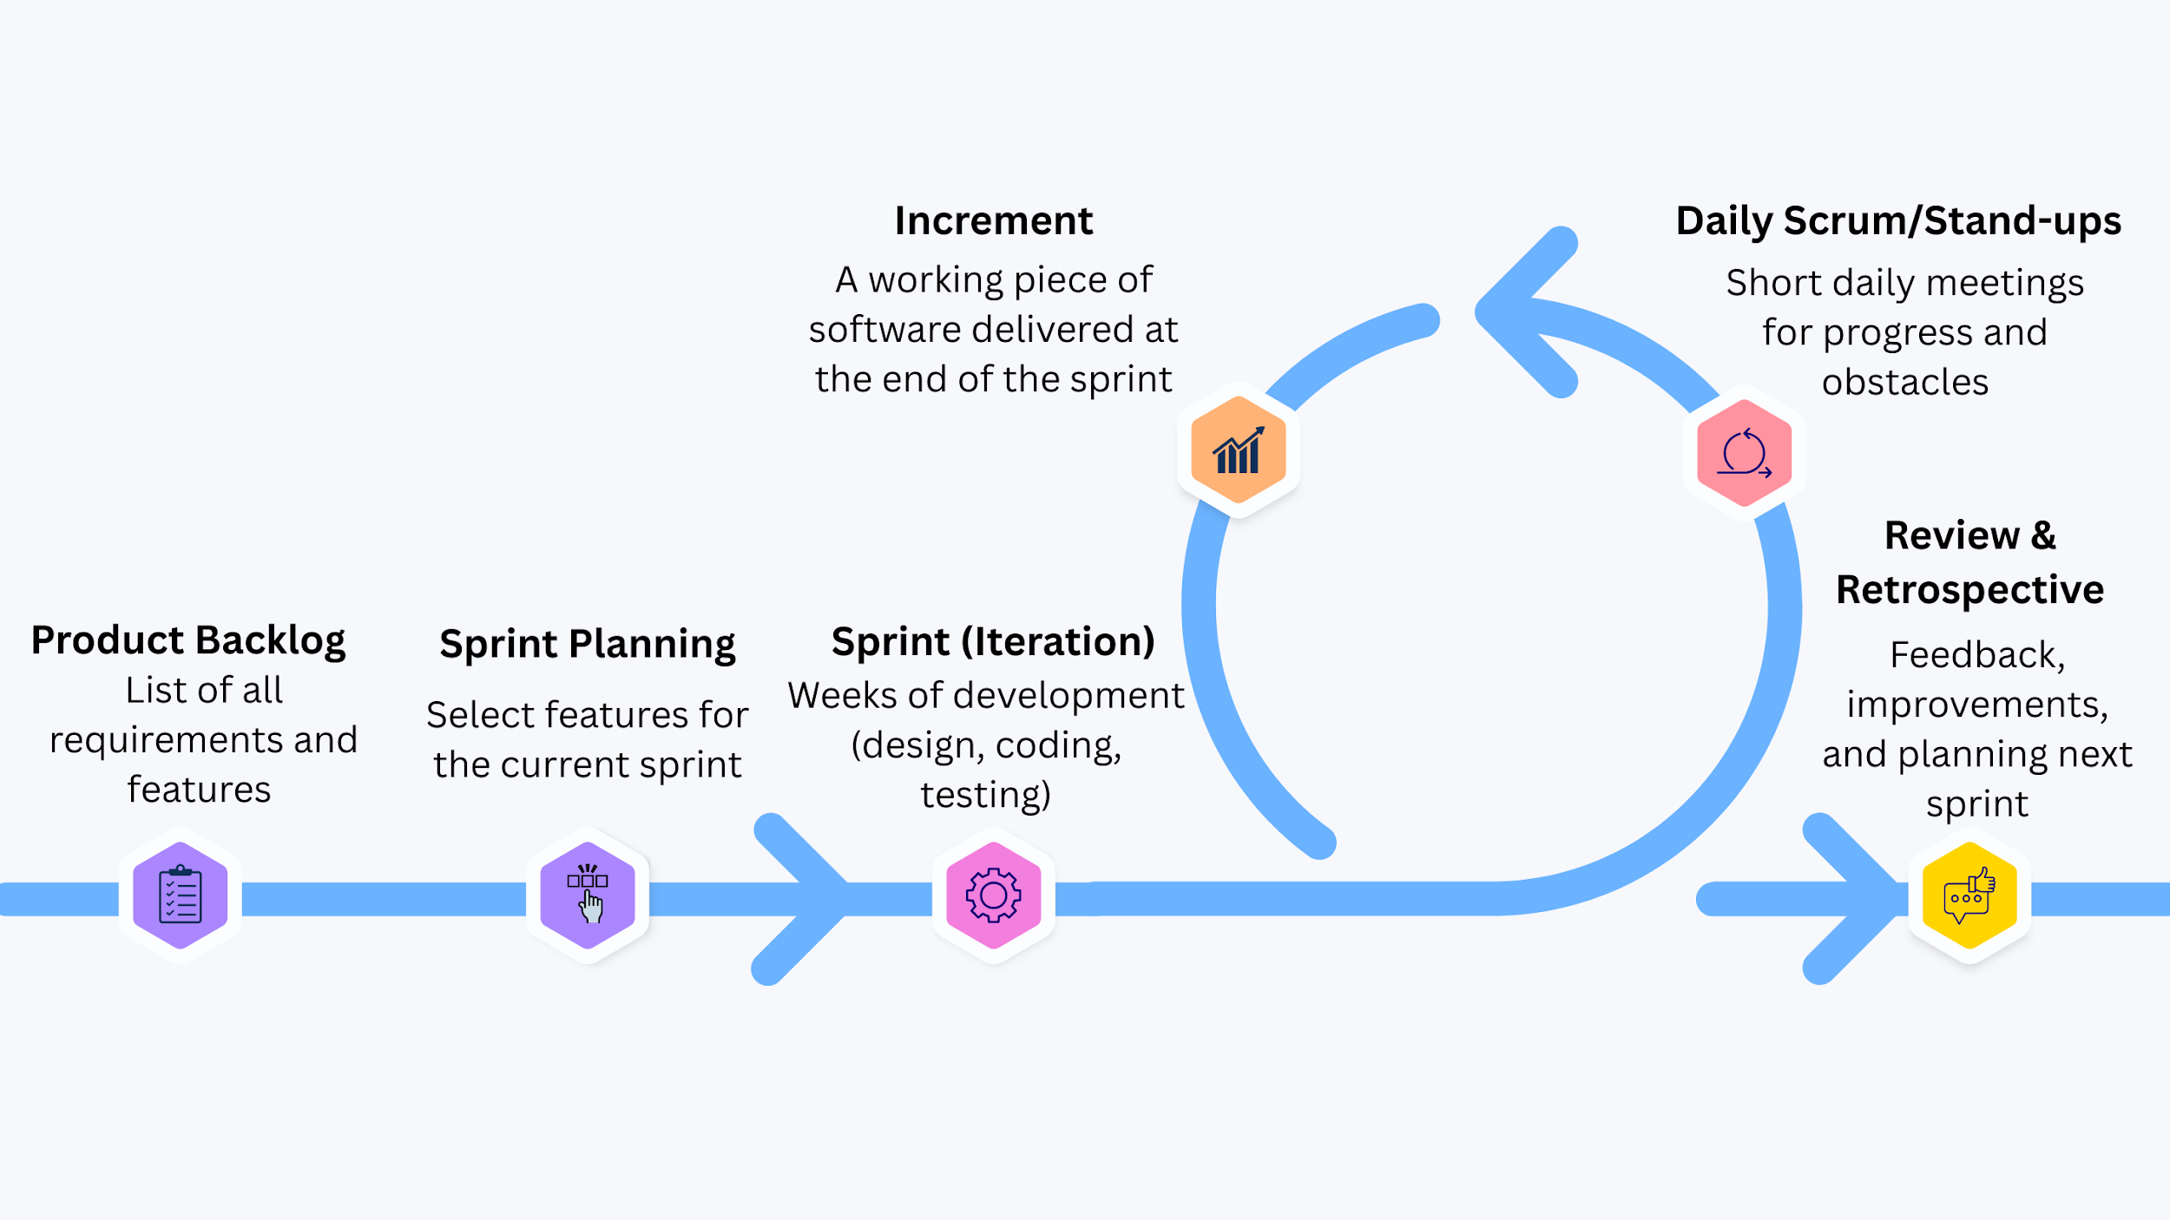
Figure 1. SDLC - Agile Model

3.1.2 Conceptual Diagram
The Conceptual Diagram found in Figure 2 shows the overall flow of data and processes in the Custom Arch-based Operating System, including input sources, the processing system, generated outputs, and the benefits for the users.
The study adopts the Agile Software Development Life Cycle to guide the design and implementation of the Custom Arch-based Operating System. Unlike the Waterfall Model, which follows a rigid sequential process, the Agile methodology is iterative and flexible, allowing continuous improvement of the system in shorter development cycles called sprints. Each sprint typically covers planning, development, testing, and evaluation, enabling the researchers to quickly adapt to changes, integrate feedback, and refine the operating system features.
In this study, the Product Backlog consists of core functionalities such as package management, driver support, security modules, lightweight desktop environment integration, and customization tools. During Sprint Planning, the research team prioritizes specific features to be developed in the sprint. The Sprint Cycle includes designing the component (e.g., system installer, GNOME environment configuration), implementing it, testing for stability and performance, and integrating it into the OS. At the end of each sprint, a Working Increment—a functional build of the operating system—is produced.
Through the Sprint Review and Retrospective, feedback is gathered from test users and evaluators to identify issues and areas for improvement. The backlog is then refined to include adjustments, new requirements, or optimizations before proceeding to the next sprint. This cycle continues until the final version of the Custom Arch-based Operating System is ready for deployment and user adoption.
INPUT block.
It is divided into three parts: Data, Users, and Devices. It covers list of what data are to be encoded into the system for processing, who are the users who will encode/provide the data for input, and what devices to use for inputting the data. The list must be left aligned inside the block. All entities here are noun and must be specific.
PROCESS block.
It refers to your proposed system. Write the complete name of the proposed system inside the block to represent all the processes in the proposed system. Proposed system name must be center aligned in the block.
OUTPUT block.
It refers to all generated results/output from the process. Outputs can be classified as Screen Output and Hard Copy Outputs. The list must be left aligned inside the block. All entities here are noun and must be specific.
BENEFITS block.
It contains the list of benefits the users can get from using the proposed system. There should be at least five benefits to support the need for the proposed system by the users. Benefit phrases must be in future tense.
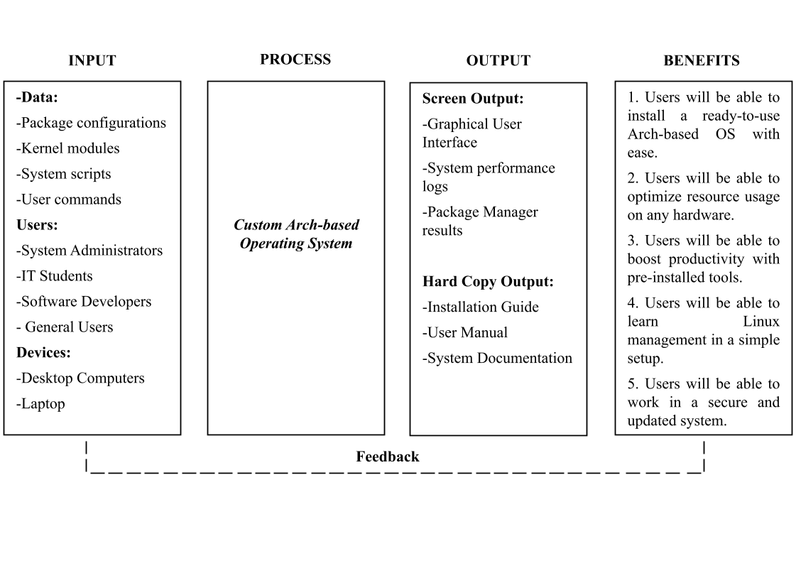
Figure 2: Input-Process-Output-Benefits (IPOB) Diagram

3.1.3 Flow of Existing System
3.1.3.1 Flowchart of the Existing System
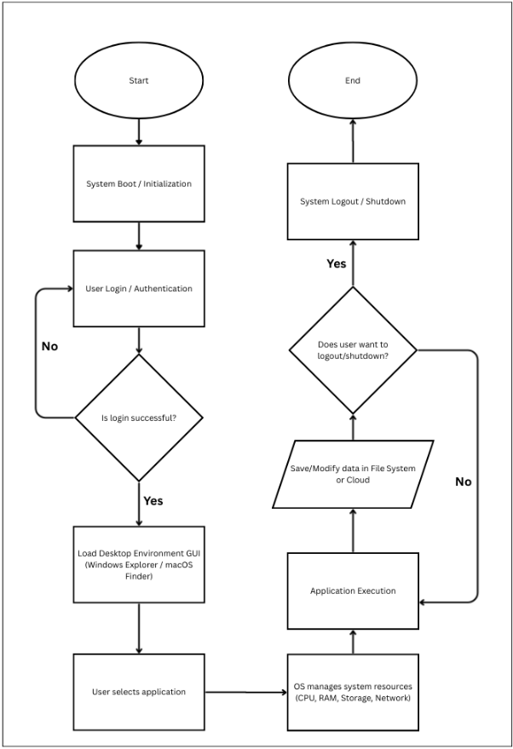
Figure 3. Flowchart of Windows and MacOS
The existing system flow, as illustrated in Figure 2, represents the operational sequence of commonly used proprietary operating systems such as Windows and macOS. The process begins with the System Boot and Initialization, during which the kernel loads essential drivers and prepares the environment for user interaction. This is followed by User Login and Authentication, ensuring that only authorized individuals gain access to system resources and personalized settings.
Once authenticated, the operating system loads the Desktop Environment or Graphical User Interface (GUI), which serves as the central interaction point between the user and the system. In Windows, this environment includes features such as the Start Menu, Windows Explorer, and Taskbar, while macOS provides alternatives like the Dock, Finder, and Menu Bar. These interfaces enable the user to easily access files, applications, and system functions. After selecting an application, the operating system manages hardware resources such as CPU, RAM, storage, and network allocation to ensure smooth and efficient operation.
During Application Execution, the user interacts with the chosen software, performing tasks such as data processing, document creation, or browsing the web. The OS continues to manage resource allocation dynamically to maintain system performance and stability. Data may be saved or modified either in the local file system (using NTFS in Windows or APFS in macOS) or in cloud storage services integrated into the system (e.g., OneDrive for Windows or iCloud for macOS). Once the session is complete, the user may choose to Logout or Shut Down, which terminates processes, saves session states when necessary, and powers down the system.
Overall, while the general flow of operations in Windows and macOS remains similar, the key differences lie in their interface design and file management systems. Windows emphasizes hierarchical navigation through Windows Explorer and application access via the Start Menu, whereas macOS offers a more application-centric interface through Finder and the Dock. These subtle distinctions highlight how proprietary systems implement user experience differently while maintaining comparable operational structures.

3.1.3.2 Data Flow Diagram of the Existing System
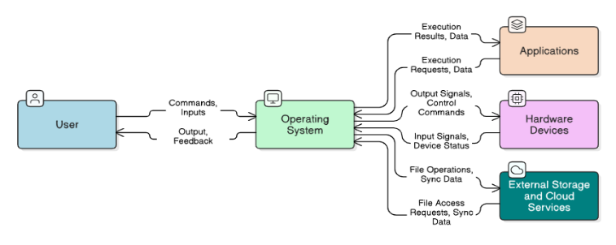
Figure 4. DFD of Windows and MacOS
(Level 0)
The Level 0 Data Flow Diagram (DFD) presented in Figure 4 illustrates the overall interaction between the user and the operating systems Windows and macOS. At this level, the operating system functions as a central process that manages communication between the user, software sources, and the computer’s hardware components. The diagram highlights how the operating system serves as the main intermediary that enables users to interact with applications and system resources.
In this model, the user sends commands and inputs to the operating system through the graphical user interface and input devices. The operating system processes these commands and provides outputs such as visual displays, notifications, and system responses. Through this interaction, users are able to execute programs, manage files, and configure system settings without directly interacting with the underlying system components.
The operating system also communicates with software repositories or application stores to obtain applications and system updates. For example, Windows typically utilizes services such as the Microsoft Store and Windows Update, while macOS uses the Apple App Store and system update services. Through these platforms, the operating system retrieves software packages and updates which are then installed and managed within the system environment.
Additionally, the operating system interacts with hardware components such as the processor, memory, storage devices, and peripheral hardware. By managing hardware communication through device drivers and system services, the operating system ensures that applications and user commands can effectively utilize the computer’s resources. Overall, the Level 0 DFD demonstrates how Windows and macOS function as centralized systems that coordinate interactions between users, software services, and hardware resources.
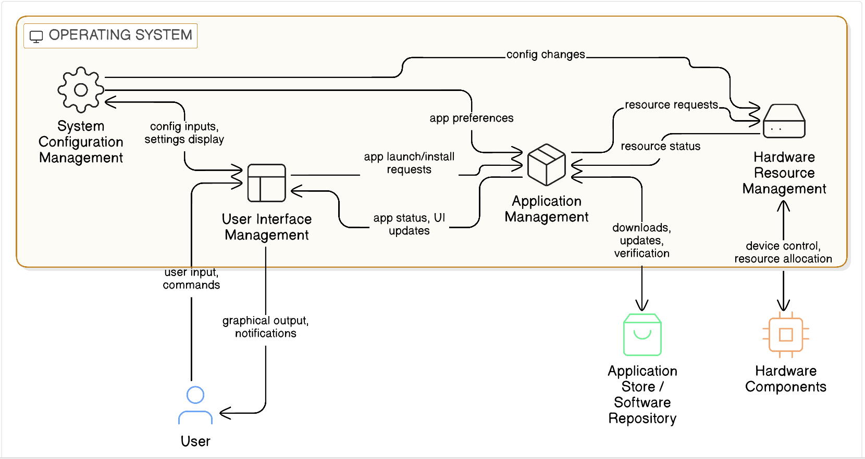
3.1.3.3 Level 1 Data Flow Diagram of the Existing System
Figure 5. DFD of Windows and MacOS
(Level 1)
The Level 1 Data Flow Diagram shown in Figure 5 expands the processes presented in the Level 0 diagram by breaking down the internal functions of the operating system into several key components. These components represent the core services that enable Windows and macOS to manage user interaction, software applications, system configuration, and hardware resources.
One of the primary processes in the diagram is User Interface Management, which is responsible for handling interactions between the user and the operating system through the graphical desktop environment. This process interprets user inputs such as keyboard commands, mouse clicks, and system requests, and then displays corresponding outputs such as application windows, menus, and notifications.
Another important process is Application Management, which controls the installation, launching, updating, and removal of software applications. This component communicates with external application repositories or software stores to download and verify programs before they are installed on the system. Once installed, applications rely on the operating system to allocate system resources and manage their execution.
The Hardware Resource Management process handles communication between the operating system and physical hardware components such as the CPU, memory, storage devices, and external peripherals. Through the use of device drivers and system services, the operating system manages hardware operations and ensures that applications can access system resources efficiently and securely.
Lastly, System Configuration Management is responsible for managing system settings, preferences, and user configurations. This process allows users to modify system behavior through configuration panels and settings interfaces. Changes made through this component can affect both application behavior and hardware operation within the system.
Overall, the Level 1 DFD provides a more detailed view of how Windows and macOS internally process user requests and system operations. By dividing the operating system into multiple functional processes, the diagram illustrates how modern operating systems coordinate software management, hardware control, and user interaction in a structured and efficient manner.
\3.1.4 Flow of Proposed System
3.1.4.1 Flow Diagram of the Proposed System
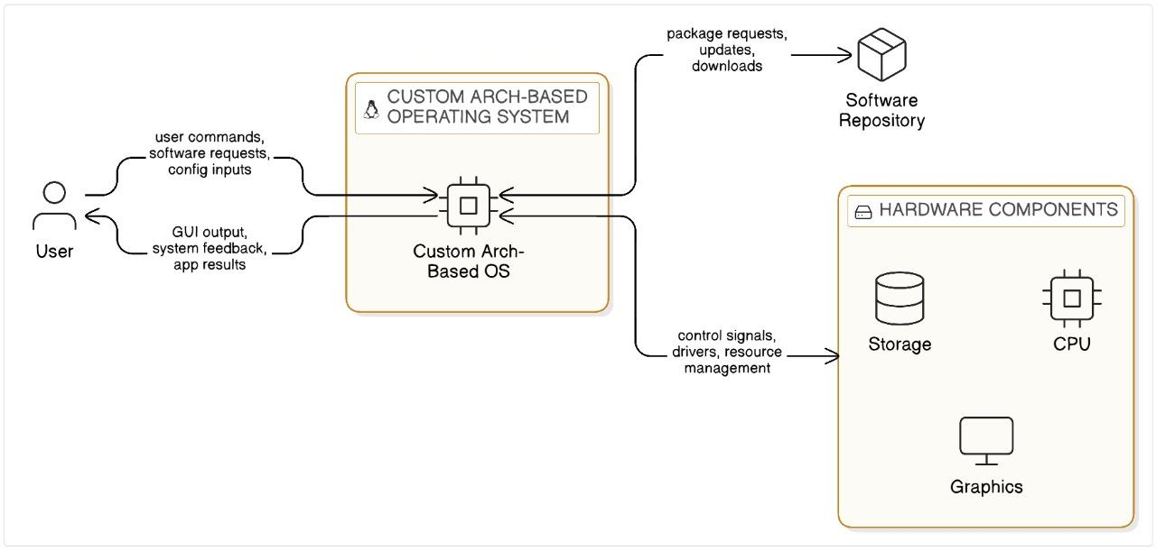
Figure 6. Data Flow Diagram of the Custom Arch OS
(Level 0)
The Level 0 Data Flow Diagram (DFD) presented in Figure 6 illustrates the general interaction between the user and the proposed system, the Custom Arch-Based Operating System. At this level, the operating system is represented as a single central process that manages communication between the user, the system’s software sources, and the hardware components of the computer. The diagram emphasizes the role of the operating system as the primary mediator that enables users to interact with the system environment.
In this model, the user provides inputs to the operating system through commands, configuration requests, and software installation actions using the graphical interface. The operating system processes these inputs and produces outputs such as graphical displays, system feedback, and application responses. Through this interaction, users are able to perform computing tasks such as browsing the internet using the Bridge Browser, managing files, and installing additional software packages.
The operating system also communicates with external software repositories that provide downloadable applications and system updates. Since the proposed system is based on Arch Linux, software packages are typically retrieved from online repositories that contain programs, libraries, and updates required by the system. The operating system sends requests to these repositories when the user installs or updates software and receives the necessary packages for installation within the system.
Furthermore, the operating system interacts with the computer’s hardware components, including the processor, memory, storage devices, graphics hardware, and other peripherals. Through built-in drivers and system services, the operating system manages communication between the hardware and the software environment. This process allows applications and system services to utilize hardware resources efficiently while keeping the complexity of hardware operations hidden from the user.
Overall, the Level 0 DFD demonstrates how the Custom Arch-Based Operating System acts as a central interface that connects users, software repositories, and hardware components within a simplified and customizable computing environment.
3.1.4.2 Level 1 Flow of Proposed System
Figure 7. Data Flow Diagram of the Custom Arch OS
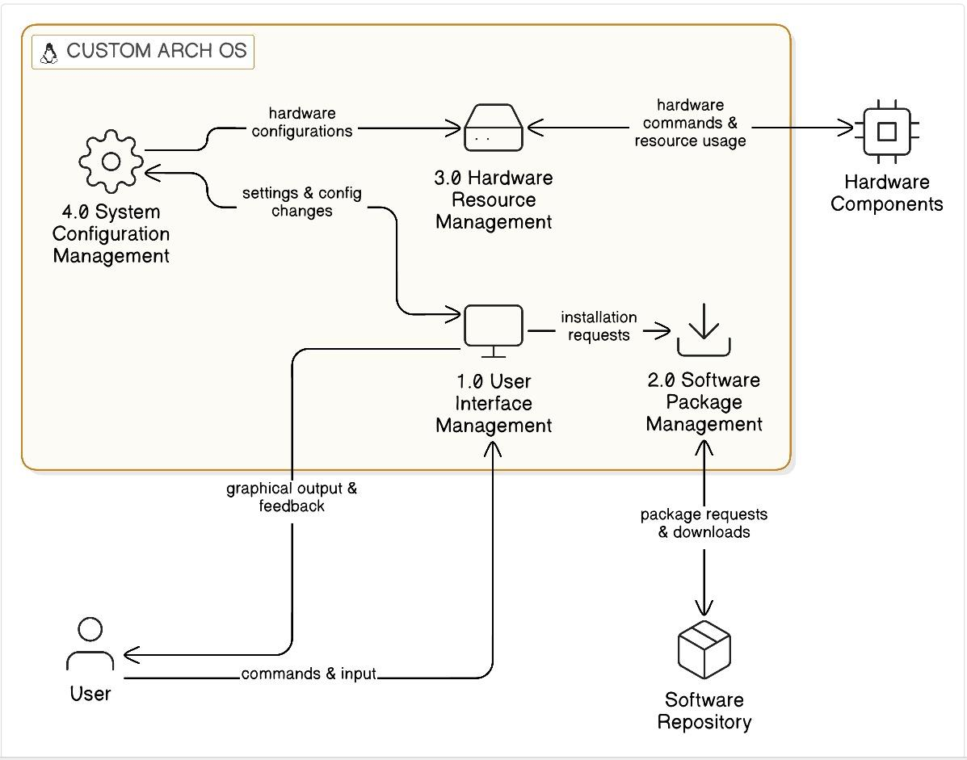
(Level 1)
The Level 1 Data Flow Diagram shown in Figure 7 expands the processes identified in the Level 0 diagram by breaking down the internal operations of the Custom Arch-Based Operating System into several major functional components. These processes represent the key services that allow the operating system to manage user interaction, software installation, system configuration, and hardware communication.
One of the primary processes in the diagram is User Interface Management, which handles interactions between the user and the operating system through the graphical desktop environment provided by GNOME. This component processes user inputs such as mouse actions, keyboard commands, and system requests, and displays outputs including application windows, menus, and system notifications.
Another essential process is Software Package Management, which is responsible for installing, updating, and removing software packages within the system. When a user requests to install or update an application, this process communicates with the external software repository to retrieve the required packages. Once the packages are downloaded, they are integrated into the operating system environment so that they can be executed by the user.
The Hardware Resource Management process manages communication between the operating system and the physical hardware components of the computer. This includes the processor, memory, storage devices, graphics hardware, and peripheral devices. Through the use of device drivers and system-level services, this component ensures that hardware resources are allocated properly and that applications can operate efficiently within the system.
Another important component is System Configuration Management, which manages user-defined settings and system preferences. Through this process, users can customize system behavior, modify configuration files, and adjust system parameters. Changes made through system configuration may influence both the user interface and hardware operations, ensuring that the operating system behaves according to the user’s preferences.
Overall, the Level 1 DFD provides a more detailed representation of how the Custom Arch-Based Operating System processes user commands and coordinates internal system functions. By dividing the system into multiple functional components, the diagram illustrates how the operating system manages software packages, hardware resources, and user interactions while maintaining the minimal and customizable design philosophy of the Arch-based system.

3.2 Requirements Documentation

3.2.1 Research Methods
This study employed the Quantitative Research Method with a Descriptive Research Design to evaluate the performance and effectiveness of the Custom Arch-based Operating System. Quantitative research emphasizes the collection and statistical analysis of measurable data, making it appropriate for assessing system performance through metrics such as benchmark results, reliability testing, and usability scores. According to Apuke, quantitative approaches are widely used to quantify and analyze variables in order to generate objective findings that can be generalized across contexts [25].
The use of a descriptive design allowed the researchers to characterize the current state of the developed system without manipulating variables. This design was particularly useful for documenting user interactions, feedback, and observed behaviors when using the Custom Arch-based OS. It provided insights into the system’s strengths and limitations in real-world usage scenarios, ensuring that both performance outcomes and user perceptions were systematically captured.
This combined approach was selected because the research required not only objective performance data but also structured user evaluations. By integrating quantitative measurement with descriptive reporting, the study ensured a balanced methodology that aligned with the goals of analyzing usability, reliability, and efficiency in comparison with existing operating systems..

3.2.2 Analysis Methods
Interview
Interviews were conducted to collect detailed qualitative information regarding users’ experiences with Arch Linux. Kvale explains that interviews provide a means of obtaining in-depth perspectives on user needs, challenges, and opinions [26]. For this study, IT students and developers were interviewed to identify common difficulties encountered when using the existing Arch-based system.
Observation
Observation was employed to systematically record user interactions during the testing phase. Creswell notes that observation enables researchers to capture user behavior and system responsiveness in real time [27]. This method was applied to monitor installation ease, system responsiveness, and user adaptation while interacting with the Custom Arch-based Operating System.
Survey/Questionnaire
Surveys are structured instruments designed to gather standardized information from multiple respondents [28]. In this research, questionnaires were distributed to evaluate the Custom Arch-based OS using the ISO/IEC 25010 quality model, focusing on eight key attributes: Functional Suitability, Reliability, Performance Efficiency, Usability, Security, Compatibility, Maintainability, and Portability. The collected responses were processed using frequency counts, mean scores, and weighted averages to ensure data consistency and reliability.
3.2.3 Scope
The scope of this project centers on the development of a modular Linux-based operating system that enables users to customize system components according to their specific hardware and software requirements. The design prioritizes a streamlined user interface, performance optimization through reduced background processes, and robust security features aimed at mitigating system vulnerabilities [7][8].
The system will be broadly compatible with a variety of hardware configurations, ensuring accessibility for users operating low-end devices. Additionally, the project seeks to provide measurable performance improvements when compared with traditional operating systems such as Windows [6].
However, the project is limited to core functionality and modular customization options, and does not cover advanced enterprise-level features such as large-scale network management or specialized virtualization environments. The focus remains on individual users and small-scale implementations, prioritizing performance, security, and adaptability within resource-constrained environments.

3.3 Technical Background

3.3.1 Product Description

The proposed system is a Custom Arch-based Operating System designed to simplify installation while maintaining the flexibility and lightweight nature of Arch Linux. It includes pre-configured settings, a user-friendly desktop environment, and optimized packages for developers and IT students.

3.3.2 Economic Use of the Product

The system provides a cost-effective alternative to proprietary operating systems. It is open-source, free to distribute, and reduces licensing costs for academic institutions and developers.

3.3.3 User Requirements
Users must have a computer equipment and have knowledge about its computer specifications
- Users must have a bootable USB drive or DVD to install the OS
- Users should have basic command line skills to handle advanced tasks for installation and troubleshooting when needed.
- Users should have access to internet
- Users should know how to create backups and recover data to protect against any potential data loss.
- Users should know how to install and manage software with package managing tools (in this case, pacman).
- Users should have basic skills in navigating the computer and managing files

3.3.4 System Requirements
- Regular users have limited access for basic tasks without changing settings or accessing private files.
- Regular users can browse the web, use pre-installed software, and access public files.
- Regular users cannot install or modify software, adjust system settings, or access private files of other users.
- Regular users are ideal for temporary users or basic tasks without making system changes.
- A superuser can install and manage software using the package manager or command line, with full control over the entire system.
- A superuser can install, modify, and remove software packages and dependencies.
- A superuser has access to all system files, including configuration and critical system files, as well as being able to mount and unmount file systems.
- A superuser can manage user accounts, permissions, and system-wide settings, such as network and security configurations
- A superuser performs advanced system tasks, including managing partitions, configuring network interfaces, and adjusting security protocols.
- A superuser can start, stop, and manage system services and daemons
- The system should be run with linux-compatible hardware
- The system must be accessible with a browser
- The system should be free to use

3.3.5 Setting and Participants
The evaluation of the Custom Arch-Based Operating System was conducted within an academic and technical environment where participants had basic knowledge of computer systems and operating system usage. The testing and evaluation activities were primarily carried out in a controlled computer laboratory and personal computing environments where the system could be installed, tested, and assessed using both virtual machines and physical hardware.
The participants of the study consisted of 30 respondents, primarily composed of Information Technology students and individuals with basic knowledge of operating systems and computer usage. These participants were selected because they are familiar with common operating systems such as Windows and Linux, making them capable of evaluating the usability, performance, and functionality of the developed system.
During the testing phase, participants were asked to interact with the Custom Arch-Based Operating System by performing common computing tasks such as navigating the desktop environment, installing software using the Pacman package manager, accessing the file manager, and using the integrated Bridge Browser. After testing the system, the participants completed a structured questionnaire based on the ISO/IEC 25010 Software Quality Model, evaluating the system in terms of functional suitability, performance efficiency, compatibility, usability, security, maintainability, and portability.
The responses gathered from the participants were analyzed using quantitative methods such as frequency counts, mean scores, and weighted averages to determine the overall performance and acceptance of the developed operating system.

3.4 Development and Testing

3.4.1 Development Process
The development of the proposed system involved creating a custom Arch-based operating system using ArchISO as the foundation. The process began with setting up the releng profile to generate a bootable ISO file. From there, the system was customized to align with the design goals of being lightweight, minimal, and user-friendly while still allowing end-users the freedom to further personalize the operating environment. The
KDE Plasma desktop environment was selected as the default graphical user interface due to its modern design, high configurability, and resource efficiency. Essential drivers and utilities were pre-installed, including network management tools, graphics drivers for both integrated and dedicated GPUs, and audio support. A minimal set of applications was included, such as the Bridge browser, which served as the default web browser. Other non-essential packages were intentionally excluded, allowing users to tailor the system to their specific needs.
Once the initial system build was completed, the ISO was tested within a Virtual Machine to ensure proper booting, installation, and functionality. This stage of development confirmed that the operating system could initialize, provide a functional desktop environment, and support basic operations. After successful virtual testing, the ISO was installed on physical hardware to evaluate real-world performance and compatibility.

3.4.2 Testing Process
Testing of the custom operating system focused on functionality, performance, hardware compatibility, and usability.
Boot and Installation Testing
The ISO was tested on both a virtual machine and a physical system. The installation process was observed to be stable, and the system booted successfully without errors.
Hardware Compatibility Testing
Drivers for critical components such as the *Ryzen 3 2200G processor, GTX 1050 Ti GPU, and TP-Link USB Wi-Fi adapter were validated. Audio output, input devices (keyboard and mouse), and display functionality under KDE Plasma were confirmed to be working correctly.
Application Testing
The Package manager (pacman), and KDE utilities were tested for stability and responsiveness. Users were able to install additional software from the Arch Linux repositories without issues.
Performance Testing
System resource usage was measured and compared with Windows and macOS. The custom Arch-based OS demonstrated faster boot times and lower memory usage at idle, owing to its minimal configuration and optimized environment.
Usability Testing
The KDE Plasma interface was evaluated for user-friendliness, including ease of navigation, customization options, and accessibility of system settings. Feedback gathered from peer testers highlighted that the system was lightweight and responsive, though some adjustments were required for first-time Linux users unfamiliar with package management.

3.5 Description of the Prototype
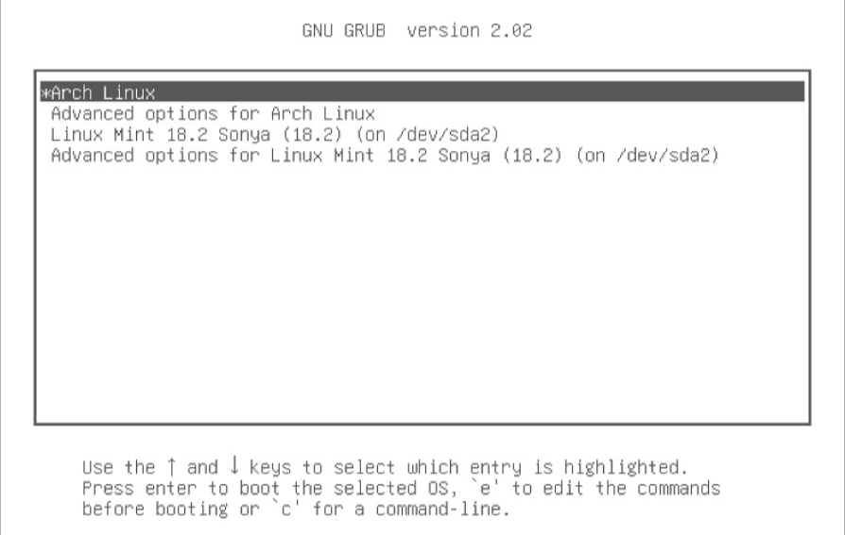
Figure 8. Bootloader (GRUB)
The Grand Unified Bootloader (GRUB) serves as the primary entry point of the system. It manages the initial boot sequence and provides the user with the option to select the custom Linux kernel or access advanced recovery modes.
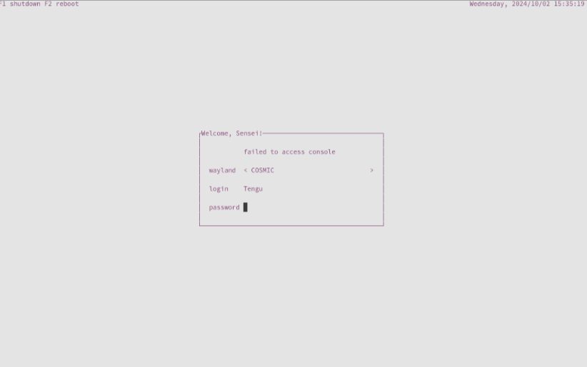
Figure 9. Display/Login Manager (ly)
The system utilizes ly, a TUI (Text-based User Interface) display manager. This lightweight component was chosen to minimize resource consumption during the initial login phase, providing a streamlined authentication process without the overhead of a heavy graphical login screen.

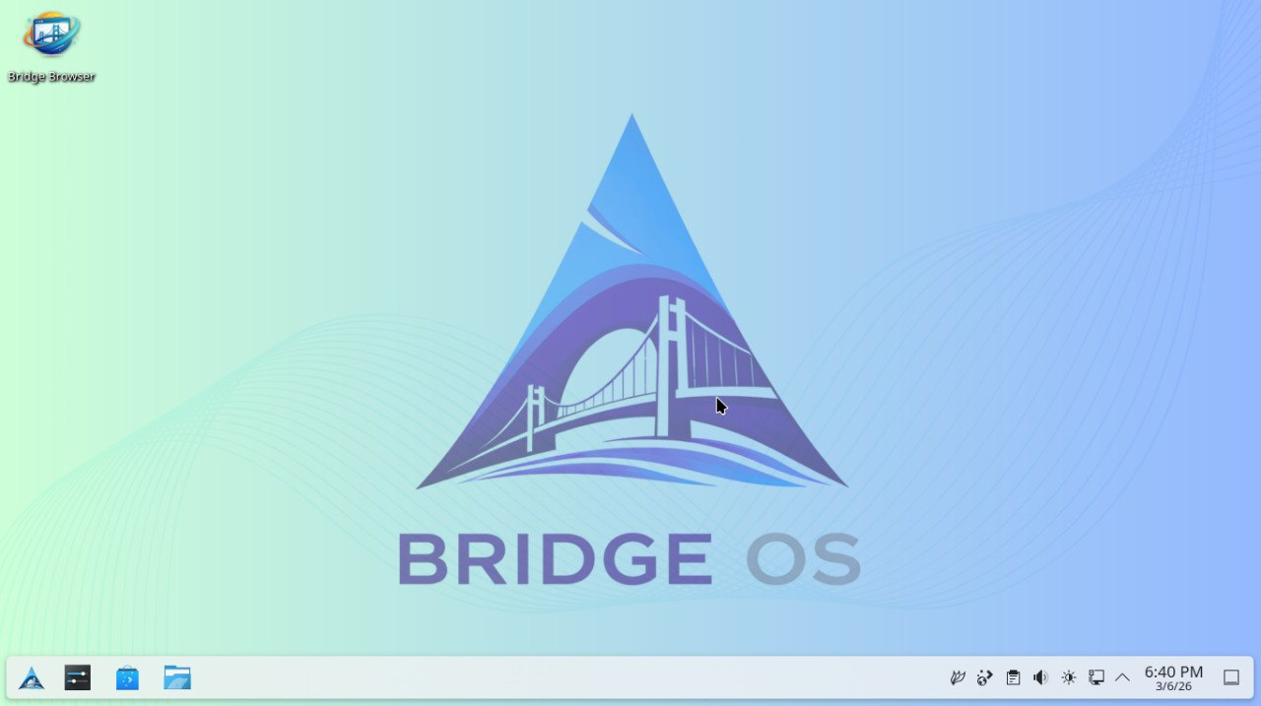
Figure 10. Desktop Environment (KDE)
The KDE Plasma desktop environment acts as the primary Graphical User Interface (GUI). It was specifically selected because its default layout and interface are highly similar to Microsoft Windows, ensuring a lower learning curve for users transitioning to a Linux-based system. Additionally, it has been specifically tuned for "low-effect" performance to ensure high responsiveness on low-end hardware while maintaining extensive visual customizability.

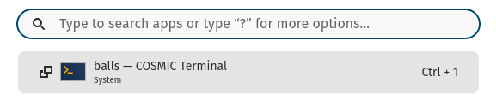
Figure 11. Application Search Engine
The integrated search engine provides a centralized interface for launching software and locating system files. It is optimized for speed, allowing users to navigate the system using keyboard-driven shortcuts.
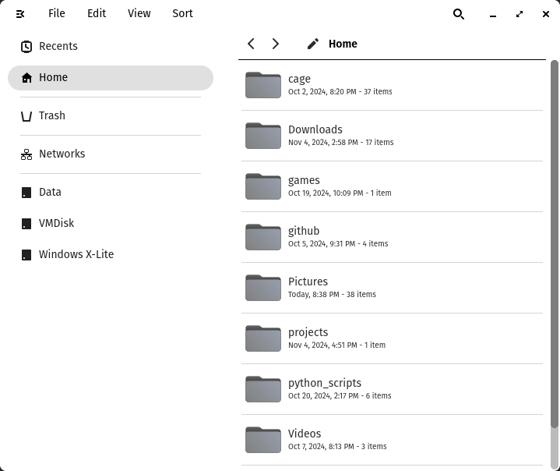
Figure 12. File Manager
The system uses the Dolphin file manager, which provides a robust and intuitive way to manage the Ext4 file system. It supports dual-pane views and integrated terminal access for advanced file manipulation.
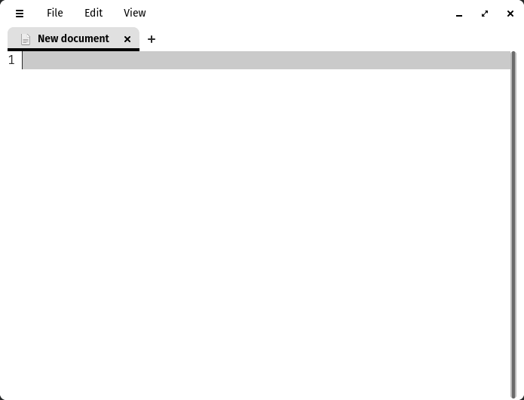
Figure 13. Text Editor
For configuration and development, the system includes a lightweight text editor. This allows users to modify system files and scripts locally with minimal memory usage.

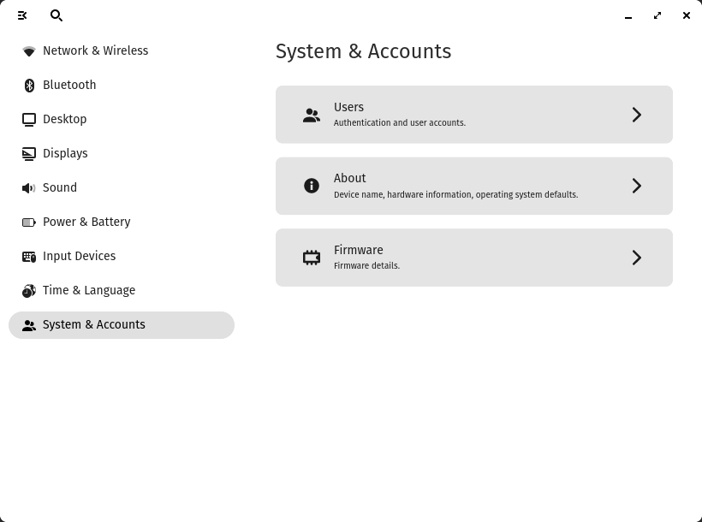

Figure 14. System Settings
This module serves as the control center for the OS, allowing users to configure hardware drivers, display resolutions, and user account permissions in a centralized, graphical interface.

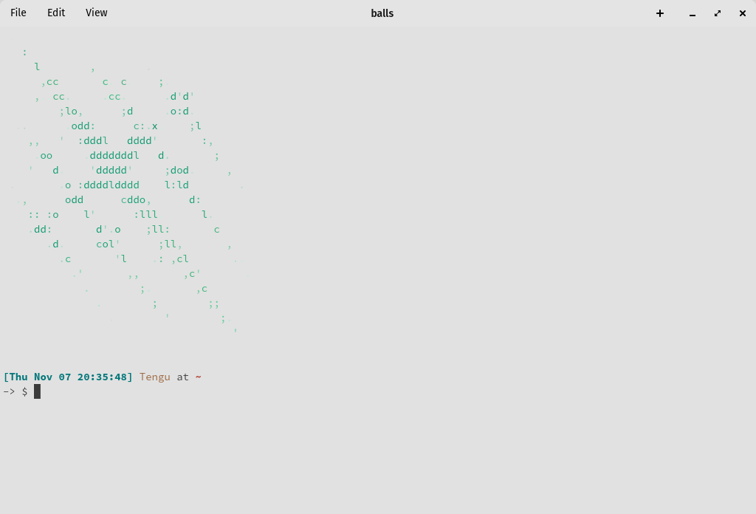
Figure 15. Terminal
The terminal is the core interaction point for the modular system. It provides access to the Pacman package manager and allows for direct system administration via the Command-Line Interface (CLI).
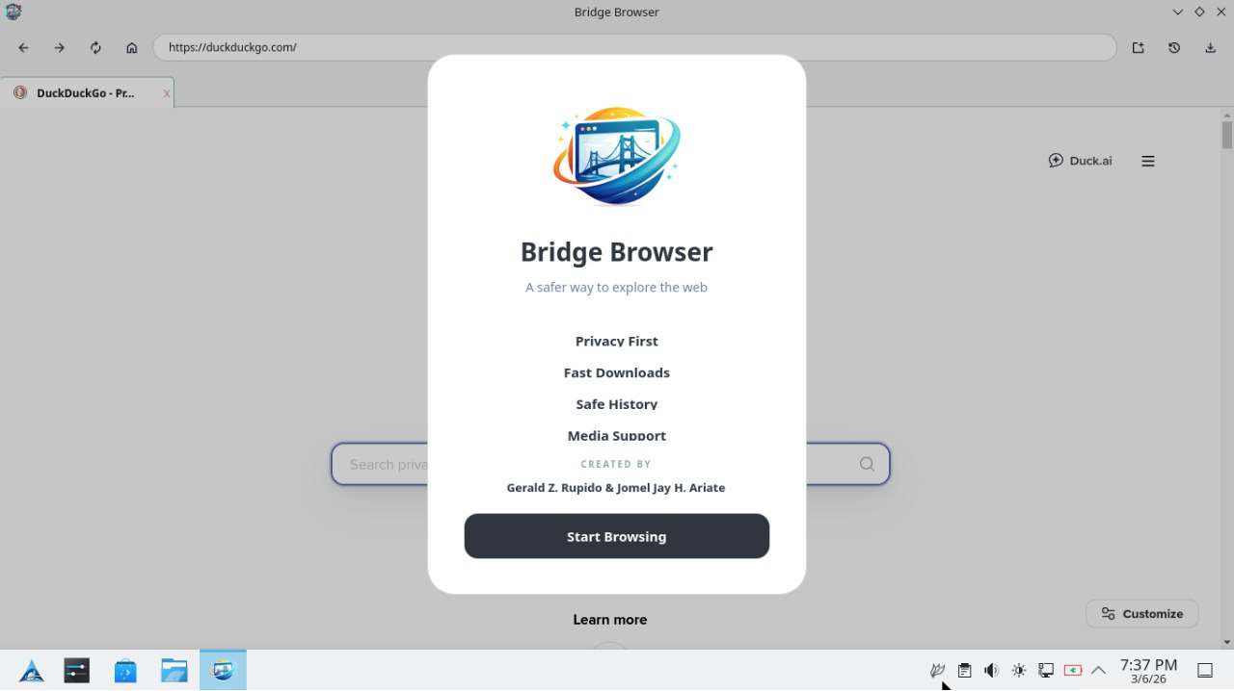
Figure 16. Bridge Browser
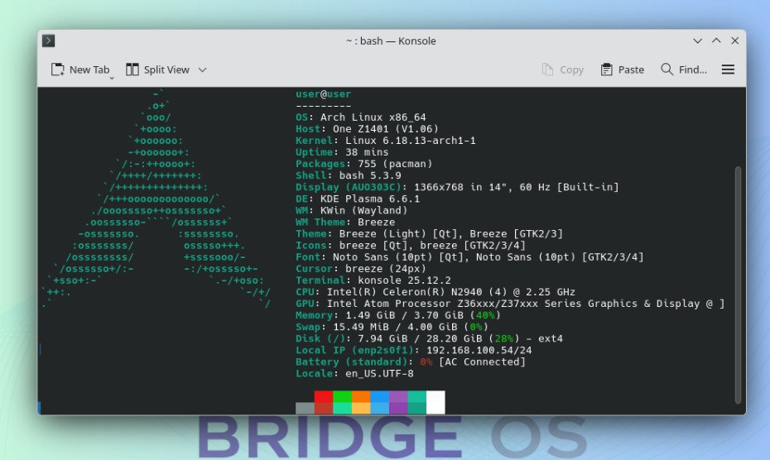
The Bridge Browser is a custom-developed web browser built using the PyQt6 framework. It was designed to provide a lightweight browsing experience tailored specifically to the system's architecture, avoiding the bloat associated with mainstream proprietary browsers.
Figure 17. System Information (FastFetch)
FastFetch is utilized to provide a quick visual summary of the system’s metadata, including the kernel version, uptime, and current theme configuration, confirming the Arch-based identity of the build.

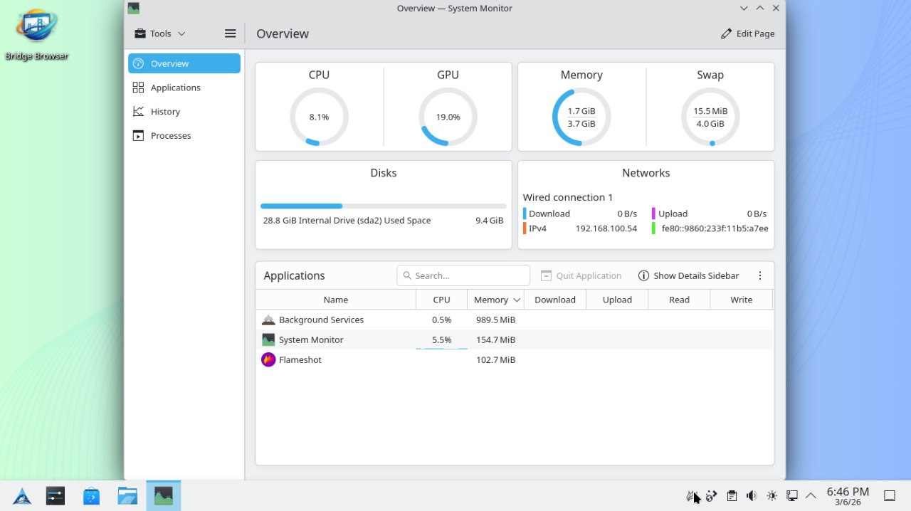
Figure 18. Resource Usage (System Monitor)
The System Monitor provides real-time reporting on hardware utilization. This confirms the system's ability to maintain a stable idle state, visually documenting the significantly lower CPU and RAM consumption compared to Windows 10.

3.6 Implementation Plan
The proposed system is a Custom Arch-based Operating System designed to simplify installation while maintaining the flexibility and lightweight nature of Arch Linux. It includes pre-configured settings, a user-friendly desktop environment, and optimized packages for developers and IT students.
3.7 Implementation Results
The expected results of implementation are:
- A functional and stable custom Arch-based OS.
- Simplified installation process compared to raw Arch Linux.
- Improved user satisfaction based on ISO 25010 metrics.
- Adoption by students and developers as a learning platform.

CHAPTER 4: RESULTS AND DISCUSSION

This chapter presents the project description, performance test results, and the final evaluation outcome of the custom Arch-based operating system.
4.1 Results
The system is a custom-built Arch Linux distribution utilizing the KDE Plasma Desktop Environment. It is designed as a modular OS that allows users to install only essential components, thereby improving performance.
- How the system runs: The system boots via the GRUB bootloader into a custom-configured Linux kernel. It uses the Pacman package manager for software handling.
- Software used: The build was developed using the Arch ISO as a base, with KDE Plasma for the Graphical User Interface (GUI).

4.1.1 Testing Project Results
The following table presents a side-by-side comparison of the custom Arch-based OS against Windows 10 (based on local testing) and macOS (based on secondary research data).

Table 1. Technical Comparison
Criteria | Windows 10 (Tested: Acer Aspire) | macOS (Secondary Data) | Custom Arch OS (Tested: Acer Celeron)
Kernel Type | Hybrid (Windows NT) | Hybrid (XNU) | Monolithic (Linux)
File System | NTFS | APFS | Ext4 / Btrfs
Avg. Boot Time | 16 Seconds (M.2 SSD) | 15 – 20 Seconds | 21 Seconds (Standard SSD)
Idle RAM Usage | 2.8 GB – 3.1 GB | 1.8 GB – 2.0 GB | 900 MB – 1.2 GB
CPU Idle Load | 5% – 100% (Spikes) | 2% – 5% | 1% – 10% (Stable)
Update Model | Semi-Annual / Forced | Annual / Versioned | Rolling Release (Pacman)
Bloatware Level | High (Edge, Telemetry) | Moderate (Ecosystem) | None (Minimalist Build)

Note: macOS data is derived from secondary research benchmarks due to hardware exclusivity.
Based on the objectives of the study and the technical evaluations conducted, the following findings were summarized:
- Kernel and Efficiency: Unlike the Hybrid kernels of Windows and macOS, the Monolithic Linux kernel used in this project allows for direct hardware interaction without the overhead of multiple abstraction layers. This is evidenced by the significantly lower RAM usage (900MB) compared to Windows 10 (2.8GB+).
- File System Performance: While Windows relies on NTFS, the custom OS utilizes Ext4, which is optimized for Linux and contributes to faster file indexing and lower system latency.
- CPU Stability: A critical finding during the testing of the Acer Aspire (Windows 10) was the frequent 100% CPU spikes. These were identified as being caused by "Edge Installer" and "Windows Telemetry" services. The custom Arch build eliminated these background processes, maintaining a stable 1–10% load, even on the lower-spec Celeron processor.
- Boot Time Context: Although Windows 10 booted faster (16s), this is attributed to the M.2 SSD hardware in the Aspire One. The custom Arch OS, running on a standard SSD, achieved a competitive 21s boot time, indicating that on identical hardware, the custom OS would likely outperform Windows 10 in startup speed.
4.1.2 Application Performance Testing
To further evaluate the efficiency of the custom Arch-based operating system, additional tests were conducted using commonly used applications. The performance of the system was compared with Microsoft Windows 10 under similar usage conditions. Direct testing with macOS was not performed in this study due to hardware limitations, as macOS is designed to run exclusively on Apple devices, which were not available for testing. This hardware exclusivity highlights one of the advantages of the developed custom operating system, as it is not tied to expensive proprietary hardware and can run on a wide range of standard computer systems [6]. Furthermore, the developed operating system is completely free and open-source, providing a cost-effective alternative for users who may not be able to afford licensed operating systems or specialized hardware.
Table 2. Application Performance Comparison
Application | Scenario | Custom Arch OS CPU | Windows 10 CPU | Custom Arch OS RAM | Windows 10 RAM
Firefox | Idle | 1% | 1% | 300 MB | 363 MB
Firefox | Loading YouTube Video | 52% | 80% | 614 MB | 706 MB
Firefox | Playing Video (720p) | 20–30% | 30–50% | 612MB | 619MB
Visual Studio Code | Idle | 1% | 2% | 285 MB | 812 MB
Visual Studio Code | Opening Folder | 34% | 86% | 340 MB | 934 MB
Visual Studio Code | Coding | 3% | 2 – 4% | 322 MB | 650 – 800 MB

The results indicate that the custom Arch-based operating system provides efficient resource utilization, particularly when running development applications.
During the testing of Firefox, both systems showed similar CPU behavior while loading video content. However, the custom Arch OS demonstrated more stable CPU usage during video playback. For development tasks using Visual Studio Code, the custom Arch system showed significantly lower CPU usage when opening project folders compared to Windows 10.
Memory usage also showed improvements in development scenarios. Visual Studio Code consumed significantly less RAM on the custom Arch OS compared to Windows 10. These findings support the claim that the modular nature of the system reduces unnecessary background processes and allows applications to run more efficiently.
4.1.3 Security Evaluation
One of the objectives of the study was to implement built-in security mechanisms that address common vulnerabilities found in existing operating systems. The custom operating system benefits from the security architecture of Arch Linux and the Linux kernel, which provide a strong foundation for system security through permission management, verified software repositories, and continuous updates [7][8].
Linux-based systems follow a strict user permission model, where administrative privileges are separated from standard user access. This design ensures that critical system operations require elevated permissions, preventing unauthorized applications from modifying system-level files without explicit approval from the user or administrator [7].
Additionally, software installation in Arch Linux is handled through the Pacman package manager, which retrieves software from official repositories. These packages are cryptographically signed and verified before installation, ensuring the integrity and authenticity of the software being installed on the system [8][19].
Another security advantage of Linux-based systems is their reduced exposure to malware designed for other operating systems. Many malicious programs are specifically developed for Microsoft Windows, making them incompatible with Linux-based environments due to differences in system architecture and executable formats [16]. Studies comparing operating system security have shown that Linux systems generally experience fewer successful malware infections because of their permission structure and lower attack surface [15].
Furthermore, malware designed for Windows environments typically cannot execute directly within Linux systems without compatibility layers or virtualization. Research analyzing malware behavior across operating systems found that many trojans and malicious executables fail to function in Linux environments because the system architecture and binary formats differ significantly from those of Windows systems [18].
Another important security feature is the rolling release update model used by Arch Linux. This model allows security patches and system updates to be distributed continuously rather than waiting for major version releases. As a result, vulnerabilities can be addressed quickly, ensuring that the operating system remains up to date with the latest security fixes [19].
4.1.4 Final Evaluation Outcome (User Review)
In addition to technical benchmarks, the system was evaluated by 30 respondents to measure its viability as a Windows alternative.
Table 2. Composite Mean
CRITERIA | COMPOSITE MEAN | VERBAL INTERPRETATION
A. Functional Suitability
1.Completeness. | 4.9 | Excellent
2.Correctness | 4.9 | Excellent
3.Appropriateness | 4.83 | Excellent
B. Performance Efficiency
1.Time Behaviour | 4.77 | Excellent
2.Resource utilization | 4.87 | Excellent
3.Capacity | 4.8 | Excellent
C. Compatibility
1 Co‑existence | 4.77 | Excellent
2 Interoperability | 4.8 | Excellent
D. Usability
1.Appropriateness recognizability | 4.83 | Excellent
2.Learnability | 4.83 | Excellent
3.Operability | 4.9 | Excellent
4.User Error Protection | 4.83 | Excellent
5.User interface Aesthetics | 4.7 | Excellent
6.Accessibility | 4.87 | Excellent
E. Reliability
1.Maturity | 4.9 | Excellent
2.Availability | 4.87 | Excellent
3.Fault Tolerance | 4.8 | Excellent
4.Recoverability | 4.67 | Excellent
F. Security
1.Confidentiality | 4.83 | Excellent
2.Integrity | 4.9 | Excellent
3.Non‑repudiation | 4.87 | Excellent
4.Accountability | 4.87 | Excellent
5.Authenticity | 4.8 | Excellent
G. Maintainability
1.Modularity | 4.83 | Excellent
2.Modifiability | 4.9 | Excellent
3.Testability | 4.83 | Excellent
H. Portability
1.Adaptability | 4.87 | Excellent
2.Installability | 4.9 | Excellent

The evaluation of the developed Arch-based operating system yielded a Composite Mean ranging from 4.67 to 4.90, which consistently falls under the "Excellent" verbal interpretation. With a total of 30 respondents—comprising students, faculty, administrators, and IT experts—the results indicate that the system meets high standards of software quality and functional performance.
The system scored exceptionally well in Functional Suitability (4.83 – 4.9) and Performance Efficiency (4.77 – 4.87). These scores suggest that the custom OS effectively performs its intended tasks without significant lag or resource drain. The high rating in Resource Utilization (4.87) is particularly noteworthy, as it validates the efficiency of the Arch Linux base, which is known for its minimal overhead compared to Windows or macOS.
Despite the common perception that Arch-based systems have a steep learning curve, the respondents rated Usability highly:
- Learnability (4.83): Indicates that the interface and navigation are intuitive enough even for non-expert users.
- User Interface Aesthetics (4.70): While still "Excellent," this was one of the slightly lower scores, suggesting that while the UI is highly functional, there is always room for minor visual refinements.
- Accessibility (4.87): Shows that the system is inclusive and easy to navigate for a diverse range of users.
Security is a critical pillar for any operating system. The survey shows strong confidence in the system's robust architecture:
- Integrity and Confidentiality (4.83 – 4.9): Respondents felt the system was secure against unauthorized access and data corruption.
- Recoverability (4.67): This represents the lowest specific mean in the dataset. While still interpreted as "Excellent," it suggests that future iterations could focus more on automated backup or system restore features to match the high standards of other categories.
The high scores in Modularity (4.83) and Analysability (4.9) reflect the inherent strengths of an Arch-based build. The system is designed such that updates or changes to one component do not negatively impact the entire environment. Furthermore, an Adaptability score of 4.87 confirms that the OS can be successfully deployed across various hardware configurations without compatibility issues.
The data confirms that the developed system is not only a viable alternative to mainstream operating systems but also excels in areas where Windows and macOS are often criticized, such as resource management and modularity. The uniformity of the "Excellent" ratings across all 30 respondents—including the IT Expert—strengthens the technical validity of your thesis.
4.2 Conclusions
Based on the findings obtained from system testing, performance evaluation, and user assessments, it can be concluded that the developed Custom Arch-Based Operating System successfully achieved the objectives of the study. The system demonstrated high functional performance and operated efficiently on low-end hardware configurations. Observations indicated stable resource consumption and significantly lower idle RAM usage compared to Microsoft Windows 10, highlighting the system as a viable alternative for devices with limited hardware capabilities.
The observed performance improvements can be attributed to the system’s modular design and the elimination of unnecessary background services commonly found in proprietary operating systems. Leveraging the Linux kernel, which follows a monolithic architecture, allowed the system to interact more directly with hardware components, reducing overhead and improving overall efficiency. As a result, the system maintained stable CPU usage and reliable performance even on lower-spec devices, such as those using Intel Celeron processors.
Furthermore, user evaluation results revealed high levels of acceptance across the ISO/IEC 25010 software quality model characteristics, indicating that the system is not only technically functional but also reliable, usable, and secure for its intended audience. Overall, this study demonstrates that a lightweight, open-source operating system can provide a practical and cost-effective alternative to proprietary platforms while maintaining acceptable performance, usability, and user satisfaction.
4.3 Recommendation
Based on the results and observations of the study, several recommendations are proposed for future improvements and further research.
First, additional hardware benchmarking should be conducted using more advanced storage technologies such as NVMe M.2 solid-state drives. This would allow future researchers to further analyze the boot-time performance differences observed during testing and determine how the custom operating system performs on newer hardware configurations.
Second, further improvements to the graphical user interface may enhance the accessibility of the system for users who are transitioning from proprietary operating systems. While the KDE Plasma environment was rated positively in terms of usability, providing a standardized desktop layout or configuration designed specifically for users migrating from Microsoft Windows may help reduce the learning curve for individuals who are less familiar with Linux-based systems.
Lastly, future development of the operating system may include the creation of specialized versions tailored to specific user needs. For example, a developer-focused edition could include pre-installed programming tools and development environments, while other versions could be optimized for educational use or lightweight general computing. Expanding the system in this way would increase its flexibility and encourage broader adoption among different groups of users.
CHAPTER 5: ACKNOWLEDGEMENT
The researchers wish to express their deepest gratitude to all those who contributed to the successful completion of this capstone project.
First and foremost, the researchers thank Almighty God for His unwavering love, grace, wisdom, and guidance, which served as the foundation of strength and motivation throughout this study.
Special thanks are extended to the families and friends of the researchers for their unfailing support and encouragement, which sustained the team during the course of this project.
The researchers would also like to sincerely thank Dr. Leonard L. Alejandro, the Capstone and Research 1 and 2 instructor, for his guidance, insightful feedback, and understanding, which greatly assisted in shaping the development and completion of this project.
Gratitude is also extended to the Open Source and Arch Linux communities, whose documentation, collaborative tools, and resources were instrumental in the technical development of the Custom Arch-Based Operating System.
Finally, the researchers express appreciation to the panelists, faculty, administrators, and the 30 survey participants, whose time, feedback, and suggestions contributed significantly to the refinement and success of this project.

References:
[1] Arch Linux. 2023. ArchWiki: Installation Guide. Retrieved September 26, 2025 from https://wiki.archlinux.org/title/installation_guide
[2] E. S. Raymond. 2003. The Art of Unix Programming. Addison-Wesley Professional, Boston, MA.
[3] Red Hat. 2021. Security-Enhanced Linux (SELinux). Retrieved September 26, 2025 from [suspicious link removed]
[4] A. S. Tanenbaum and H. Bos. 2015. Modern Operating Systems (4th ed.). Pearson, Upper Saddle River, NJ.
[5] M. Ballejos. 2024. Windows OS: Strengths and Limitations in Modern Computing. Journal of Software Engineering 12, 3 (2024), 45–57.
[6] J. Adekotujo, F. Li, and P. Wong. 2020. Evaluating macOS Usability and Compatibility in Professional Environments. International Journal of Human-Computer Studies 85, 4 (2020), 120–135.
[7] C. Eckert. 2012. Linux Security Fundamentals. Springer, Berlin, Germany.
[8] A. Singh. 2023. Linux System Security: Hardening Techniques for Modern Computing. O’Reilly Media, Sebastopol, CA.
[9] S. Negus. 2021. Practical Linux for Developers and Users. Apress, New York, NY.
[10] M. Ramos. 2003. Bayanihan Linux v2: A Government Initiative Toward Open Source Adoption. Advanced Science and Technology Institute (ASTI) Technical Report.
[11] R. Reyes. 2023. Free and Open Source Software as a National Strategy for Data Sovereignty in the Philippines. Philippine Journal of ICT Research 15, 2 (2023), 88–104.
[12] M. Trapero, L. Santos, and J. Dela Peña. 2019. Factors Affecting the Acceptance of Free and Open-Source Software in Philippine Higher Education. Asian Journal of Education and e-Learning 7, 3 (2019), 45–56.
[13] J. Bautista. 2022. Linux Adoption in Philippine Public Schools: A Sustainability Perspective. Philippine Education Technology Journal 9, 1 (2022), 33–49.
[14] A. Cruz and R. Villanueva. 2021. Adoption of Linux-Based Systems in Philippine Municipal Offices: Security and Piracy Reduction. Government ICT Review 5, 2 (2021), 77–92.
[15] L. De La Cruz. 2023. Comparative Security Analysis of Windows, Linux, and macOS. International Journal of Cybersecurity Studies 10, 1 (2023), 1–17.
[16] Y. Bassil. 2012. A Comparative Study on the Security of Windows and Linux Operating Systems. Journal of Computer Science Issues 9, 3 (2012), 456–461.
[17] H. Zhang, W. Liu, and M. Chen. 2021. Performance Impacts of Linux Security Modules: A Study of SELinux in Linux v5.3. IEEE Transactions on Dependable and Secure Computing 18, 6 (2021), 2801–2813.
[18] A. Al-Saadoon and A. Al-Bayatti. 2011. Analyzing Trojan Behaviors on Windows and Linux Using Packet Inspection. International Journal of Information Security 10, 4 (2011), 287–296.
[19] T. Peterson. 2024. Open-Source Collaboration and Security Patch Management in Linux. Journal of Information Systems Security 20, 2 (2024), 134–150.
[20] Computerworld. 2025. Why Linux is Considered the Most Secure Operating System. Computerworld Magazine (2025).
[21] Information Array. 2025. Comparative Security Review: Windows, macOS, and Linux. Information Array Reports (2025).
[22] Wikipedia and RebootPoint. 2025. macOS Security Features: SIP, Gatekeeper, and More. Retrieved September 26, 2025 from https://en.wikipedia.org/wiki/macOS_security
[23] Canonical Ltd. 2023. Linux in Cloud Infrastructure: Adoption and Security. Canonical Reports (2023).
[24] Red Hat. 2024. Enterprise Linux Security Hardening: A White Paper. Red Hat Publications (2024).
[25] H. Apuke. 2017. Quantitative Research Methods: A Synopsis Approach. Kuwait Chapter of Arabian Journal of Business and Management Review 6, 10 (2017), 40–47.
[26] S. Kvale. 2007. Doing Interviews. SAGE Publications, London, UK.
[27] J. W. Creswell. 2014. Research Design: Qualitative, Quantitative, and Mixed Methods Approaches (4th ed.). SAGE Publications, Thousand Oaks, CA.
[28] A. Fink. 2013. How to Conduct Surveys: A Step-by-Step Guide (5th ed.). SAGE Publications, Thousand Oaks, CA.
[29] S. Shrivastava and S. Sahu. 2023. A Comparative Study of Operating Systems: Case of Windows, Mac and Linux. ResearchGate Technical Report. Retrieved from https://www.researchgate.net/publication/369245267_A_Comparative_Study_of_Operating_Systems_Case_of_Windows_Mac_and_Linux

List of Appendices

APPENDIX A
Certificate of Implementation


Arellano University - JAS
College of Information Technology Education

This is to certify that the project entitled “Development of Custom Arch-Based Operating System with a Comparative Study on Windows and MacOS” has been successfully implemented by the undersigned researchers. The project was meticulously developed, designed, and executed in alignment with the objectives outlined in the approved research proposal. It has undergone comprehensive testing and evaluation to ensure that its core features—including the modular Linux kernel configuration, KDE Plasma desktop environment optimization, automated package management via Pacman, and the elimination of background telemetry and bloatware—are fully functional and effectively support its intended goal to provide a high-performance, secure, and lightweight computing alternative for low-end hardware.
Furthermore, this certification affirms the researchers’ commitment, effort, and collaboration in bringing this project to fruition. As fourth-year college students, their successful implementation of the operating system demonstrates a high level of technical proficiency in system architecture, problem-solving ability, and preparedness to tackle real-world challenges through open-source innovation. The project reflects not only their academic growth but also their dedication to creating a meaningful tool to modernize and optimize the computing experience for students and IT professionals.

Beneficiary:

Name & Signature:

Researchers:

Name & Signature: ARIATE, JOMEL JAY H..
Name & Signature: RUPIDO, GERALD Z.
Name & Signature: SORITA, PRINCE F.

Date Signed:

APPENDIX B
Sample Input/ Output/ Report

Screen Output:
-Graphical User Interface
-System performance logs
-Package Manager results

Hard Copy Output:
-Installation Guide
-User Manual
-System Documentation

-Data:
-Package configurations
-Kernel modules
-System scripts
-User commands
Users:
-System Administrators
-IT Students
-Software Developers
- General Users
Devices:
-Desktop Computers
-Laptop

Custom Arch-based Operating System
1. Users will be able to install a ready-to-use Arch-based OS with ease.
2. Users will be able to optimize resource usage on any hardware.
3. Users will be able to boost productivity with pre-installed tools.
4. Users will be able to learn Linux management in a simple setup.
5. Users will be able to work in a secure and updated system.
INPUT
PROCESS
OUTPUT
BENEFITS
Feedback
Figure 1: Input-Process-Output-Benefits (IPOB) Diagram
Figure 2. Bootloader (GRUB)

Figure 3. Display/Login Manager (ly)

Figure 4. Desktop Environment (KDE)

Figure 5. System Information (FastFetch)

Figure 6. Resource Usage (System Monitor)

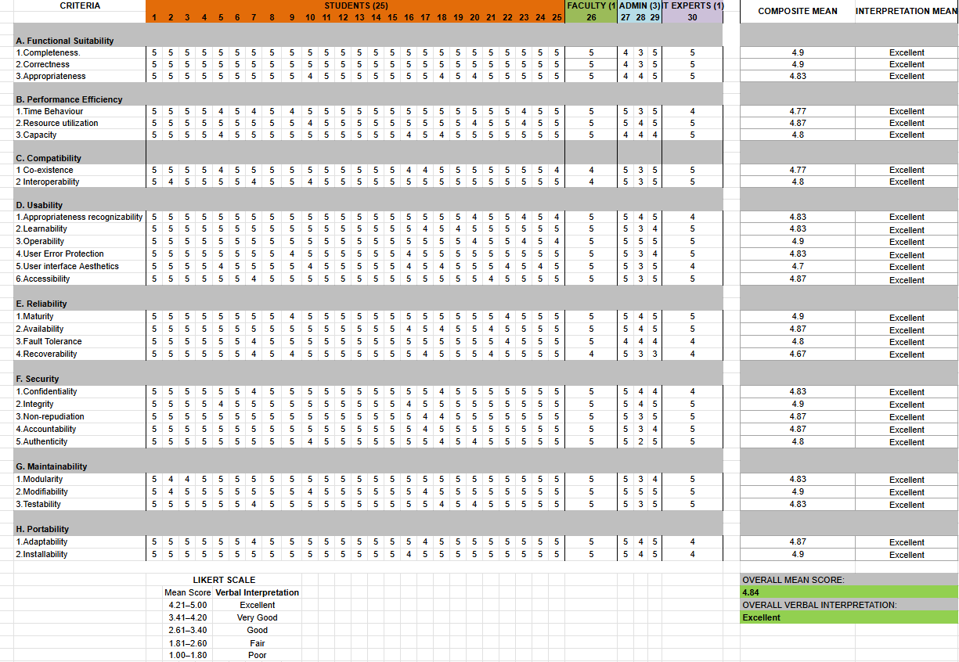
APPENDIX C
Presentation of Findings
Figure 1: Detailed presentation of findings
\

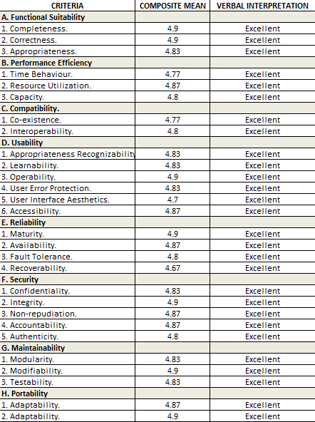
Figure 2: Concluded Presentation of Findings
APPENDIX D
Evaluation Tool/ Test Documents (Three Samples)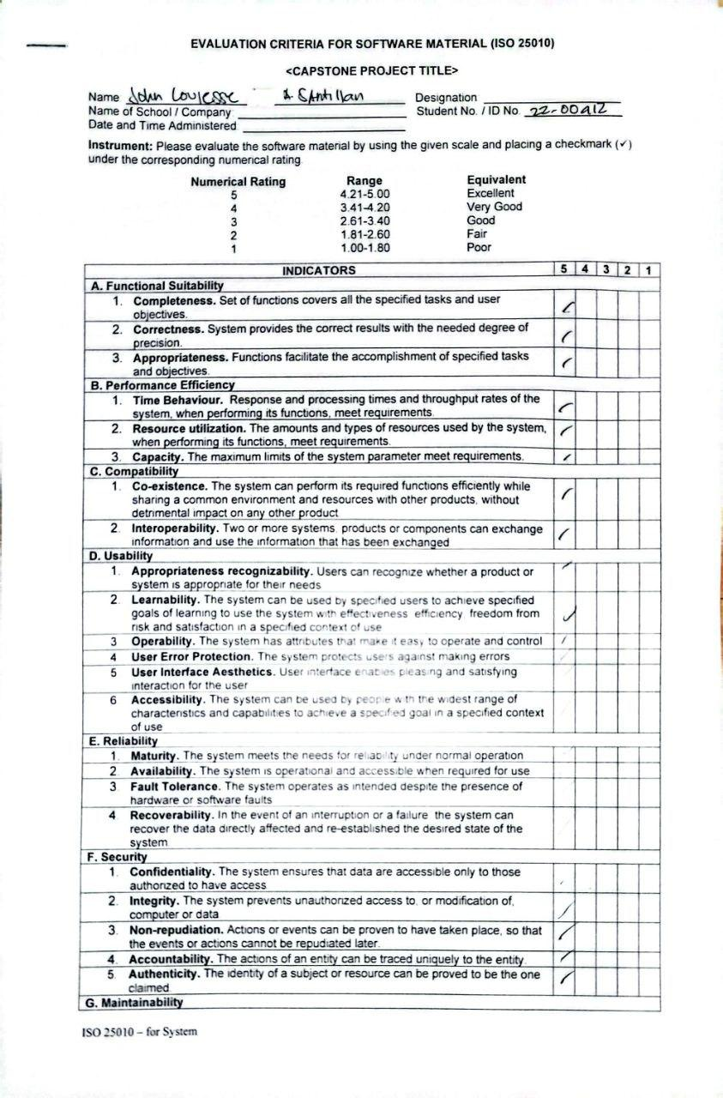
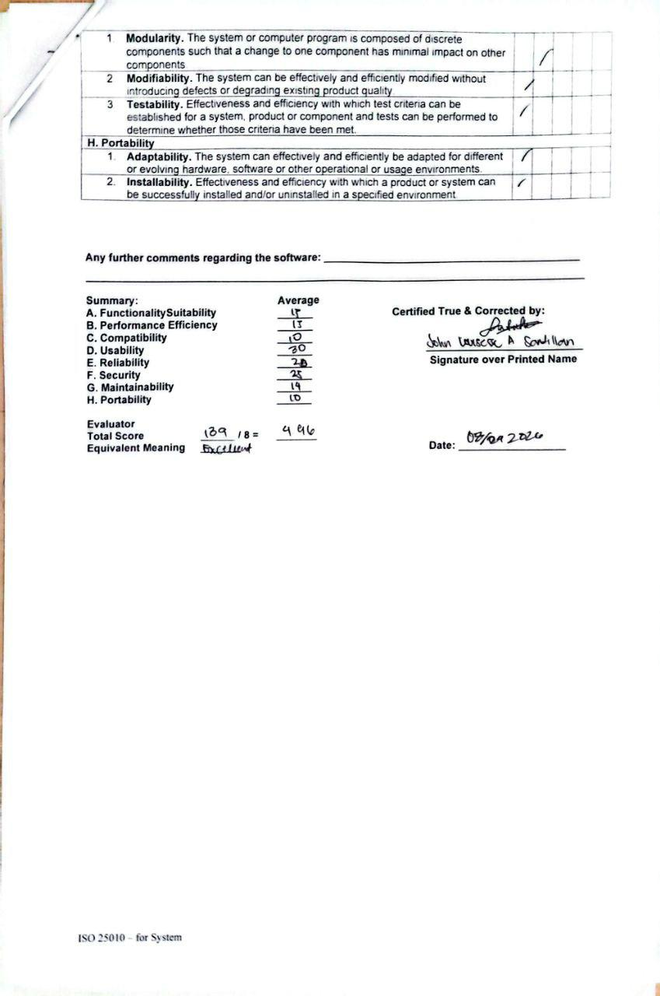
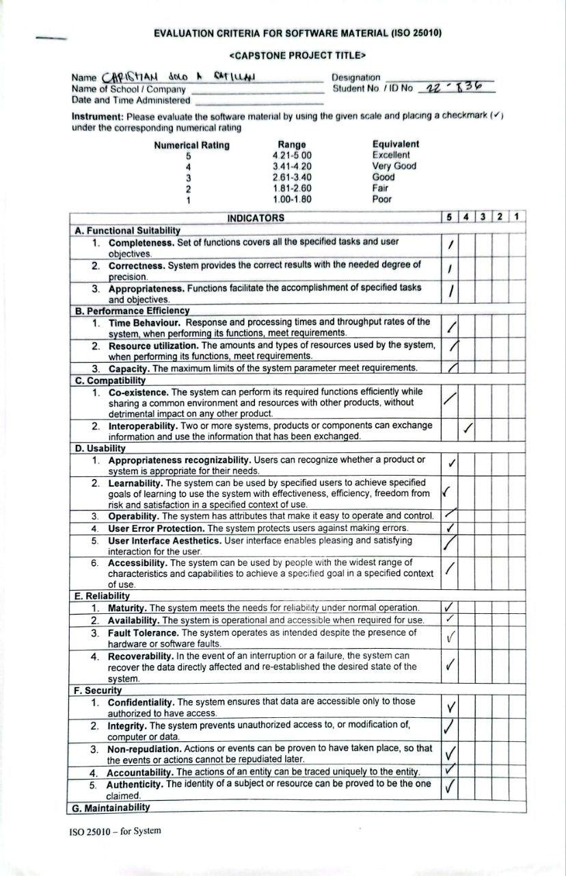
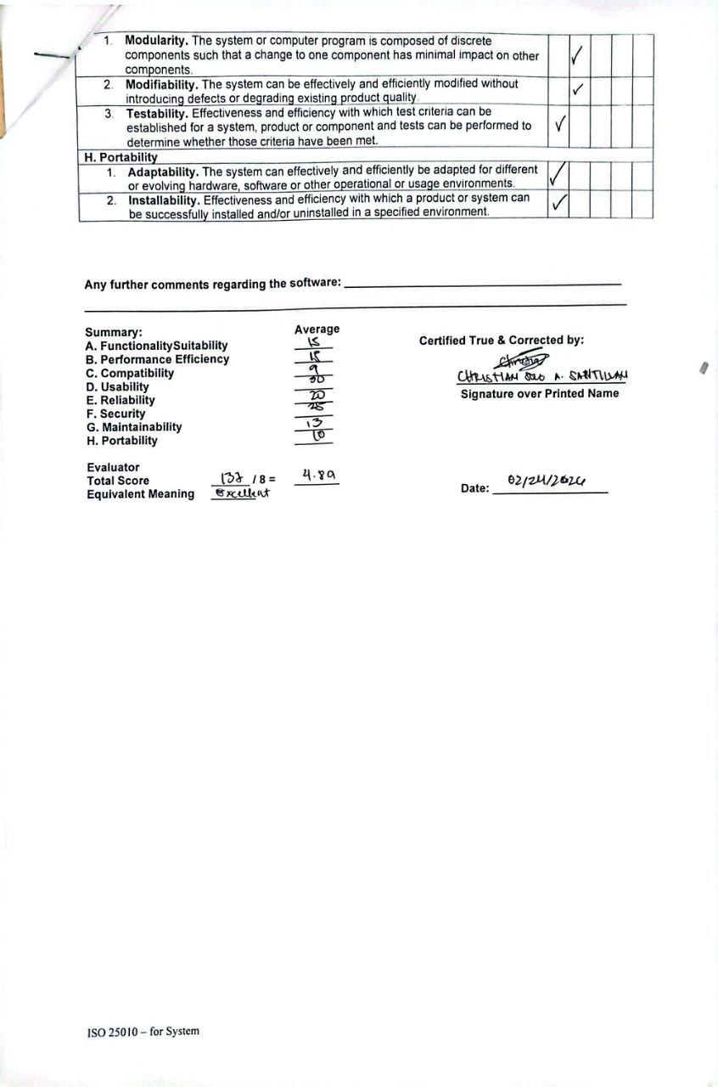
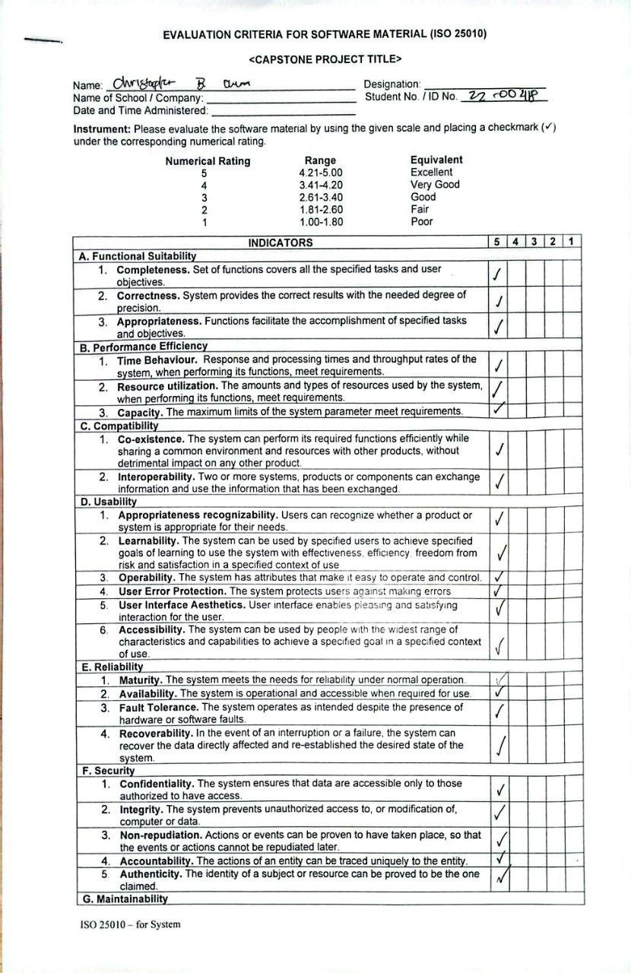
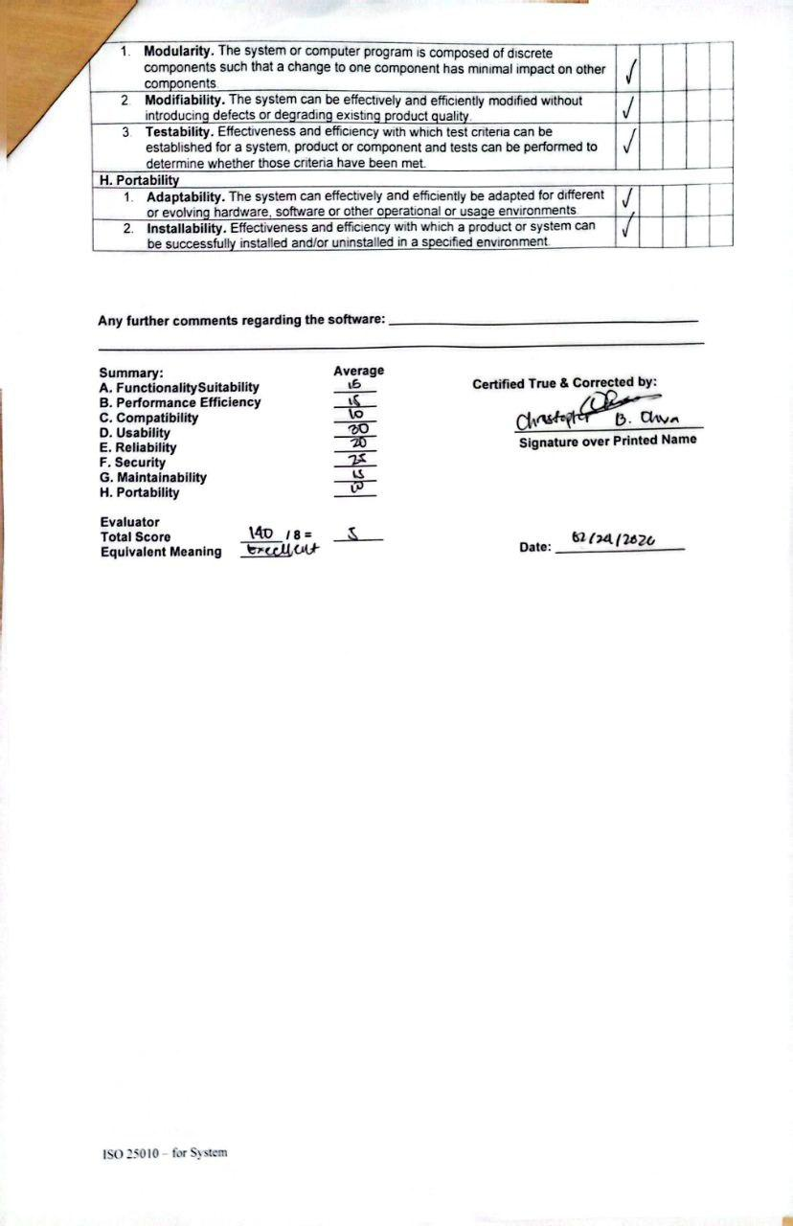
APPENDIX E
Certificate of Initial and Final Testing
Initial Testing Approval Sheet

In partial fulfilment of the requirements for the degree of BACHELOR OF SCIENCE IN COMPUTER SCIENCE, this thesis project in Thesis 2 entitled “Development of Custom Arch-Based Operating System with a Comparative Study on Windows and MacOS” has been prepared by: Jomel Jay H. Ariate, Gerald Z. Rupido and Prince F. Sorita who are hereby recommended for initial testing of the system to the beneficiary.

________________________________________
Dr. Leonard Alejandro
Technical Adviser

Final Testing Approval Sheet

In partial fulfilment of the requirements for the degree of BACHELOR OF SCIENCE IN COMPUTER SCIENCE, this thesis project in Thesis 2 entitled “Development of Custom Arch-Based Operating System with a Comparative Study on Windows and MacOS” has been prepared by: Jomel Jay H. Ariate, Gerald Z. Rupido and Prince F. Sorita who are hereby recommended for initial testing of the system to the beneficiary.

________________________________________
Dr. Leonard Alejandro
Technical Adviser

APPENDIX F
Gantt Chart of Developmental Schedule
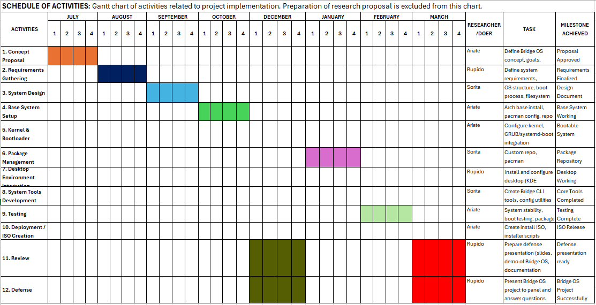
Figure 1: Gantt Chart of Developmental Schedule.
The project schedule was structured to transition from theoretical planning to full technical implementation over an eight-month period covering Thesis 1 and Thesis 2. The first semester, spanning July to October, focused on the research and design phase, where the team established the Bridge OS concept, finalized requirements, and designed the system architecture and filesystem layout. This foundational work was essential to ensure the system met the high standards for functional suitability and portability later confirmed in the evaluation.
The second semester shifted into development and testing, starting in December with the configuration of the custom Linux kernel and GRUB bootloader. Throughout January and February, the team integrated the KDE Plasma desktop environment and developed custom system tools, such as the PyQt6-based browser. Rigorous performance testing was conducted during this time to validate the system's "Excellent" efficiency rating. The timeline concluded in March with the creation of the final ISO medium and the successful project defense.
This progression was supported by a clear division of labor, with Ariate handling core technical modules and ISO deployment, Rupido managing user requirements and documentation, and Sorita overseeing system design and utility development. This collaborative effort ensured all milestones were met, leading to the final release of Bridge OS v1 in March.
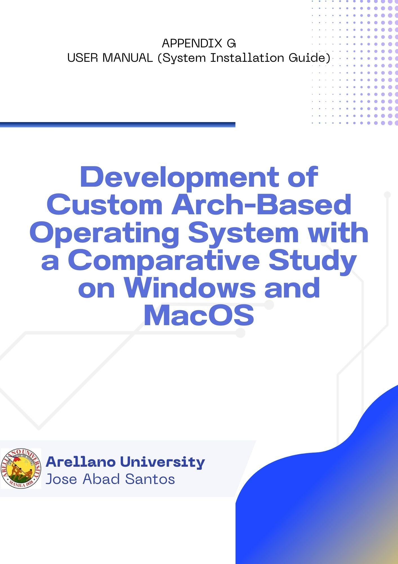

INTRODUCTION
This section provides a step-by-step technical guide for the proper installation and configuration of the custom Arch-based operating system.

TABLE OF CONTENTS
TABLE OF CONTENTS
Pages
INTRODUCTION………………………………………………………………………..…….….2
TABLE OF CONTENTS………………………………………………………………………….2
GETTING STARTED……………………………………………………………………………..3
Boot Configuration………………………………………...…………………………………….3
Authentication…………………………………………………………………………………...4
Initialization……………………………………………………………………………………..4
Region Settings………………………………………………………………………………….5
Input Configuration……………………………………………………………………………..6
Storage Allocation………………………………………………………………………………6
User Personalization…………………………………………………………………………….8
Final Verification………………………………………………………………………………..9
Execution and Completion……………………………………………………………………..10

GETTING STARTED

Welcome to the Custom Arch-Based Operating System developed for the study “Development of Custom Arch-Based Operating System with a Comparative Study on Windows and macOS.” This system is designed to provide a lightweight, customizable, and efficient computing environment based on the Arch Linux framework.

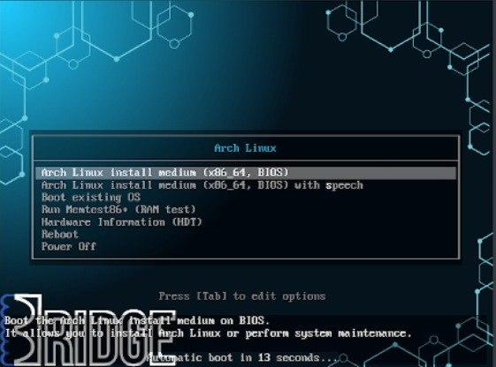

Step 1: Boot Configuration (GRUB Menu)
Insert the installation medium and boot the hardware. When the GRUB bootloader screen appears, select the "Arch Linux Install Medium" option to initialize the live environment.

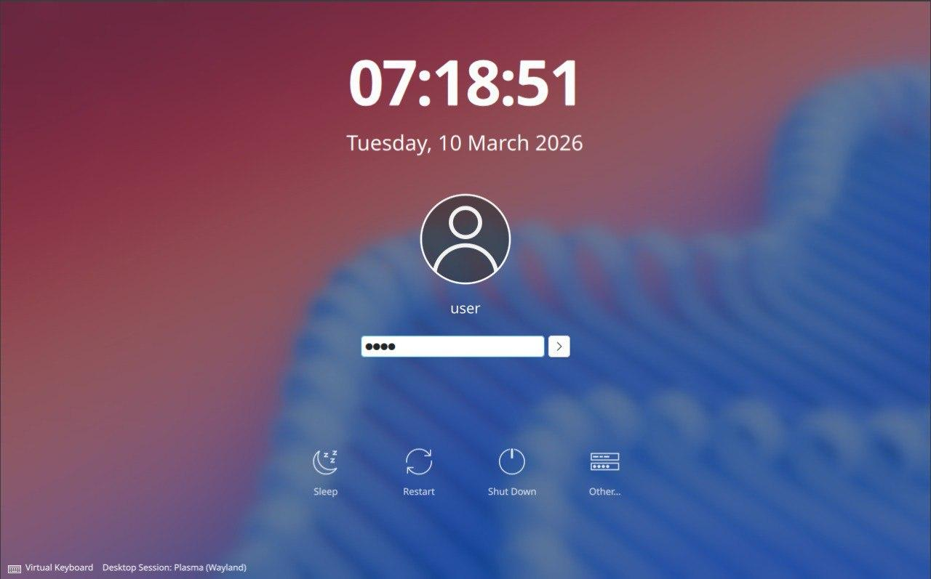
Step 2: Authentication (Login Manager)
Once the live environment loads, the system will prompt for administrative access. Enter the default password "1234" in the Login Manager to proceed to the desktop.

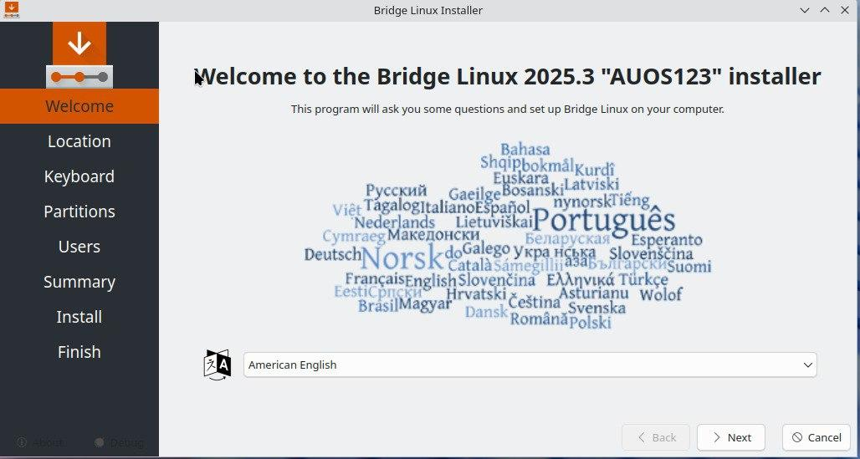

Step 3: Initialization (Calamares Installer)

The first screen is the Welcome module; select your preferred Language from the dropdown menu to set the localization for the installation process.
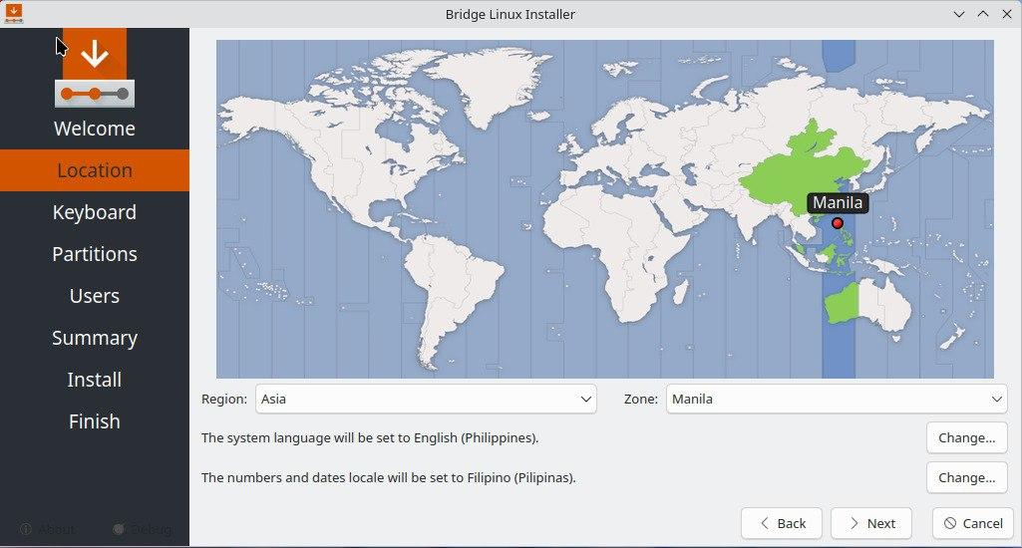

Step 4: Regional Settings (Location)

Select your specific Geographic Location and Time Zone. This ensures the system clock and regional formats are correctly synchronized with the local environment.

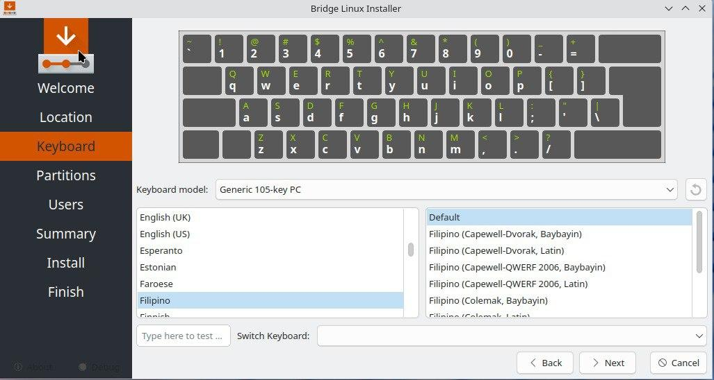

Step 5: Input Configuration (Keyboard)

Select the appropriate Keyboard Layout. The proponent recommends the "English (US)" default to ensure compatibility with standard terminal commands.

Step 6: Storage Allocation (Partitioning)
This critical step defines how the OS will be stored. Users are presented with four distinct methods:

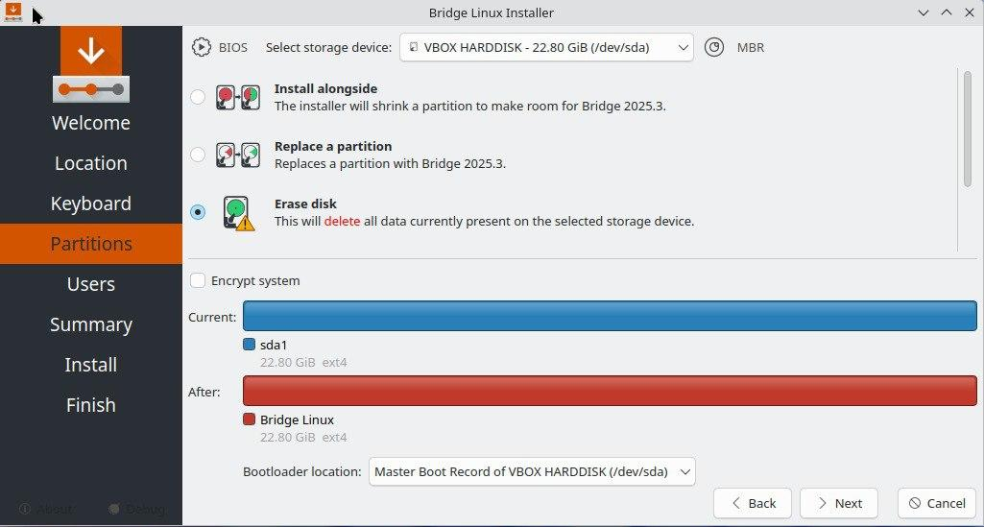
Erase Disk: Select this if the storage is empty or if all existing data should be deleted to make room for the new OS
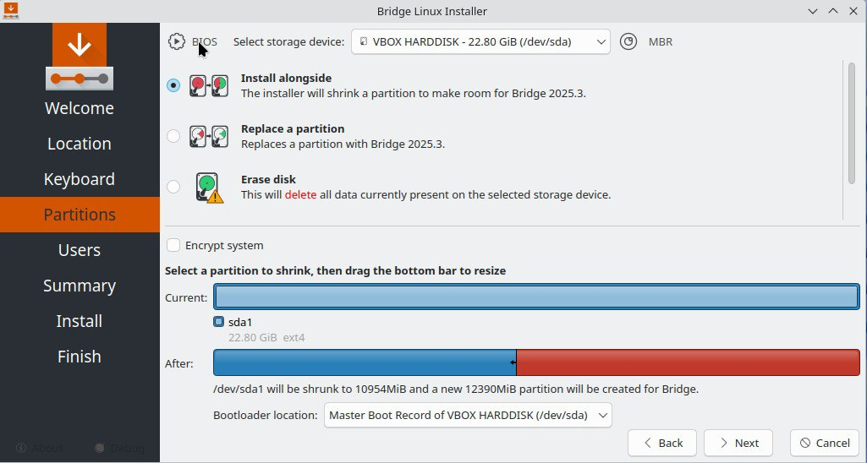.
Install Alongside: The installer will automatically shrink an existing partition (such as Windows) to create space for the custom Arch build.

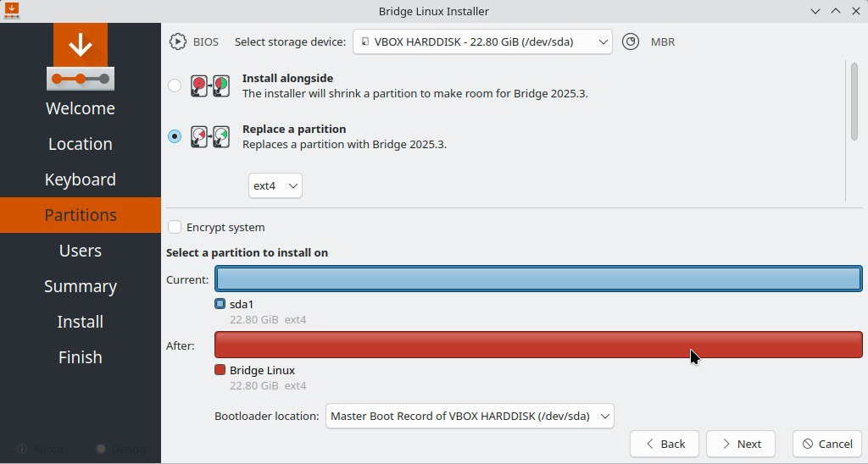
Replace a Partition: Choose this to overwrite a specific existing partition while leaving others untouched.

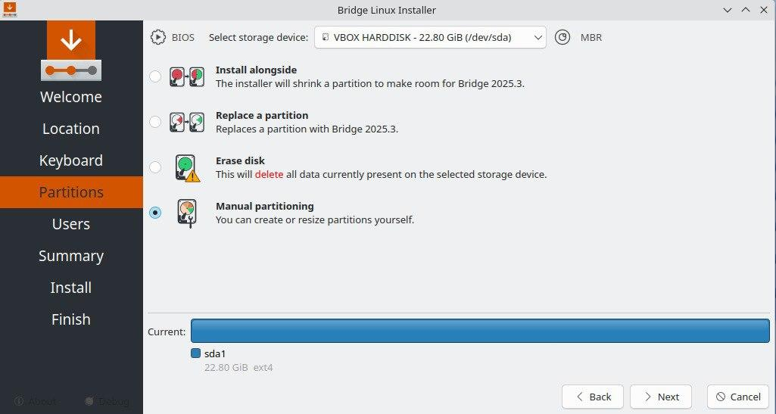
Manual Partitioning: For advanced users who wish to manually define the Root, Swap, and Home partitions.

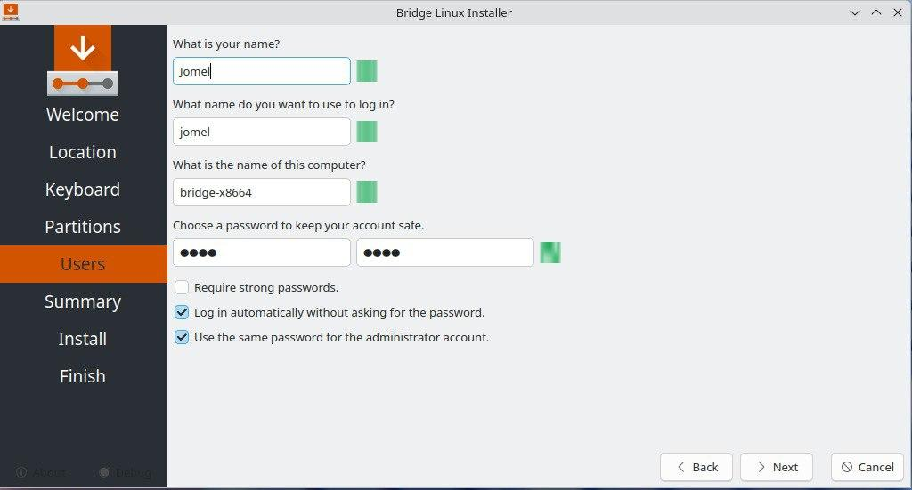
Step 7: User Personalization (User Setup)
Fill out the required fields to create the primary administrative account. This includes the User's Name, the PC Hostname, and the System Password.
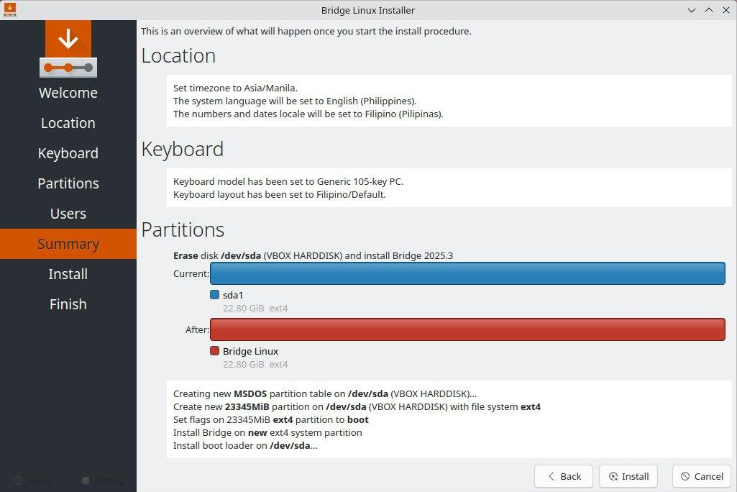
Step 8: Final Verification (Summary)
The Summary module displays a complete overview of the chosen configurations. The user must double-check the partition changes and regional settings before committing to the installation.

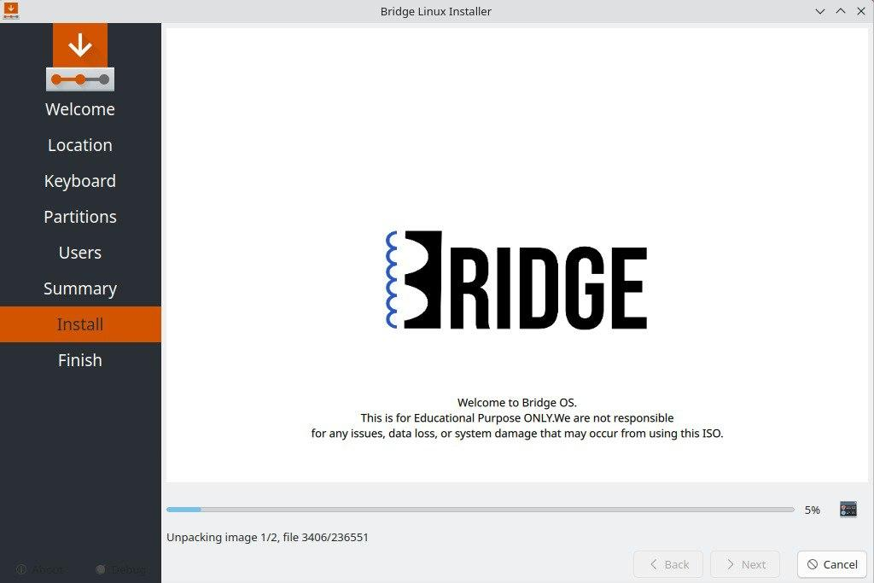
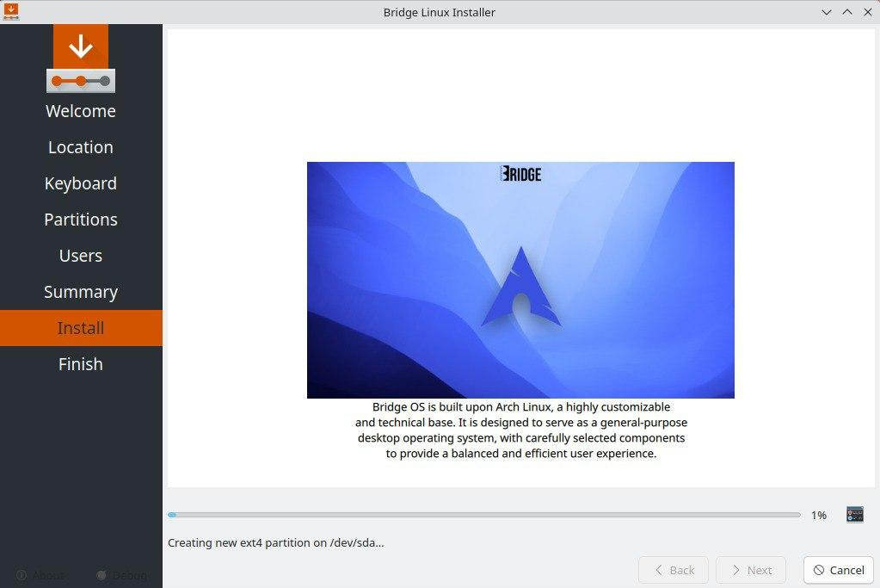

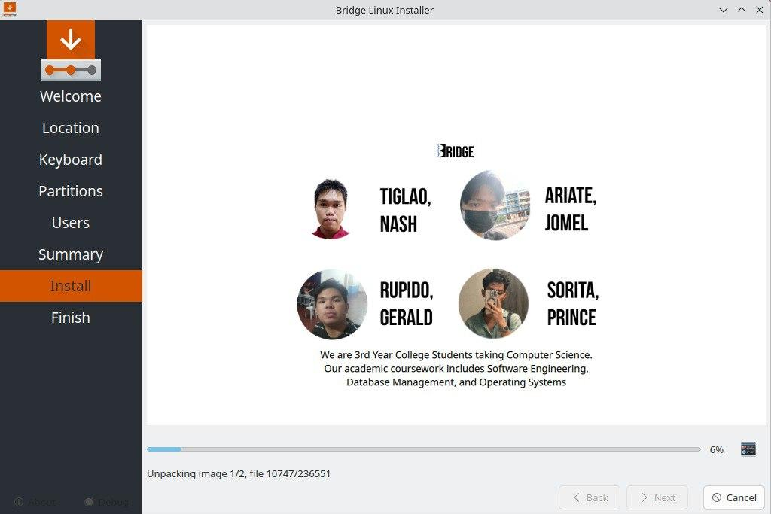

Step 9: Execution and Completion
Click "Install" and wait for the progress bar to reach 100%. Once the process is finished, restart the system to boot into your newly installed custom Arch-based Operating System.

APPENDIX H
Documentation Photos
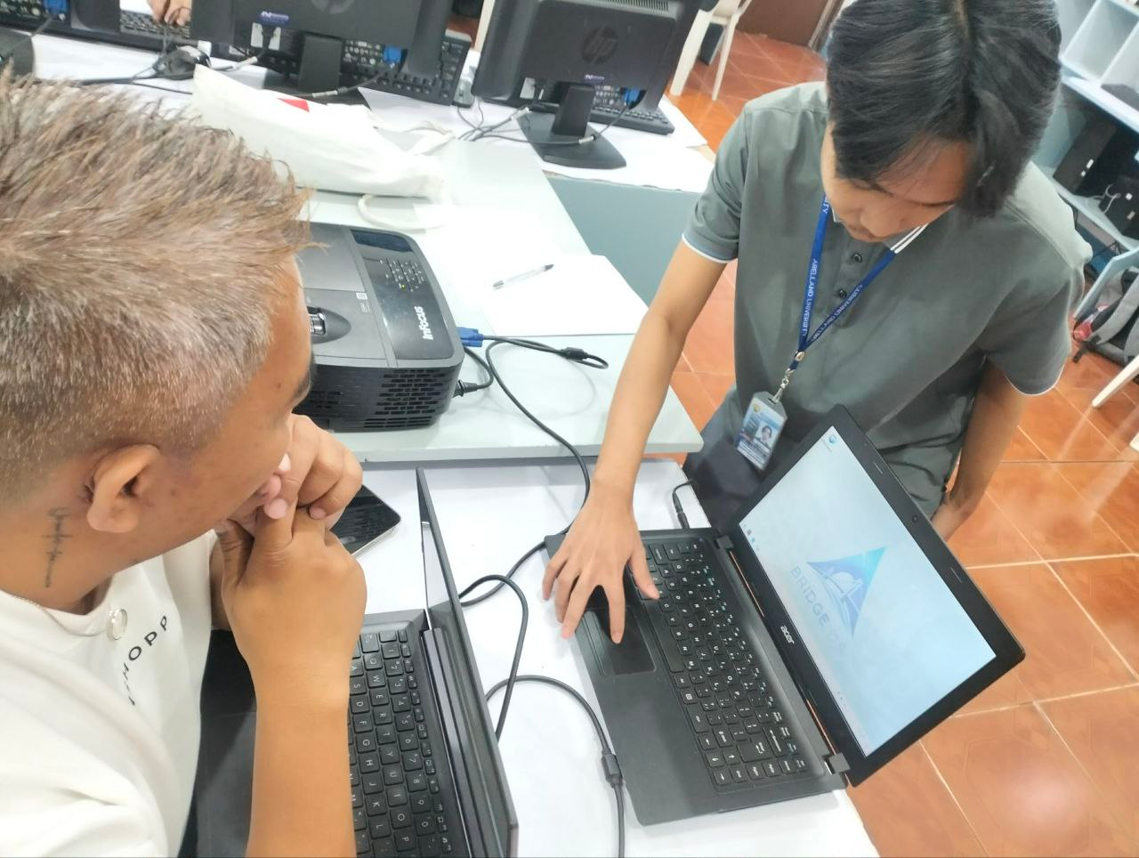
Figure 1: Testing and evaluation with faculty
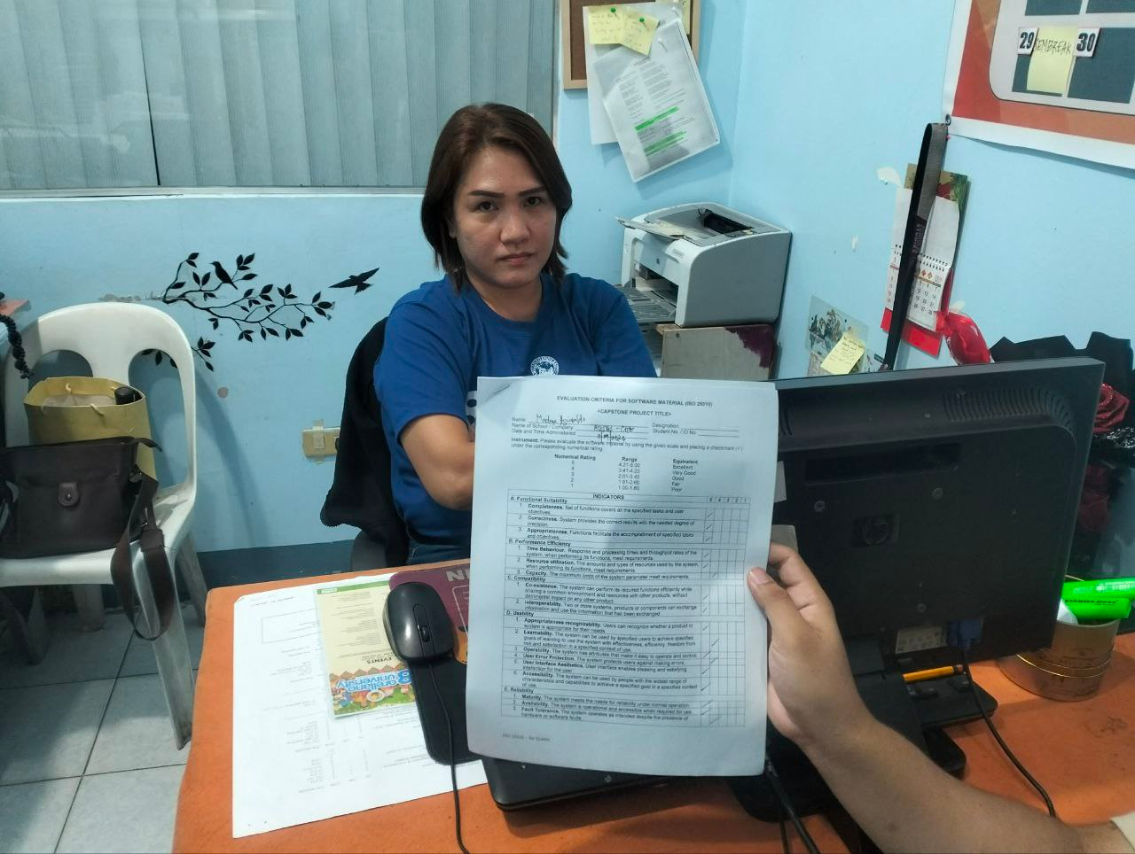
Figure 2: Testing and evaluation with Dean’s Secretary

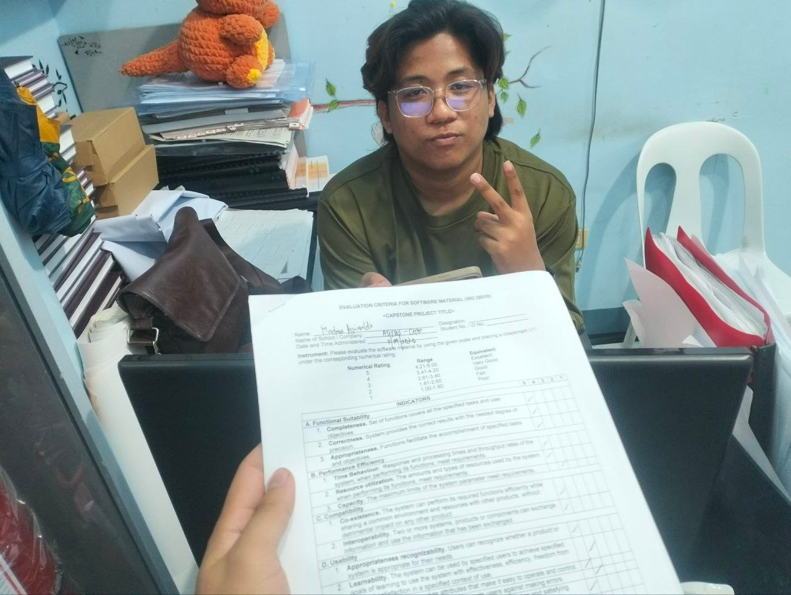
Figure 3: Testing and evaluation with custodian


Figure 4: Testing and evaluation with IT Expert (Software Engineer)

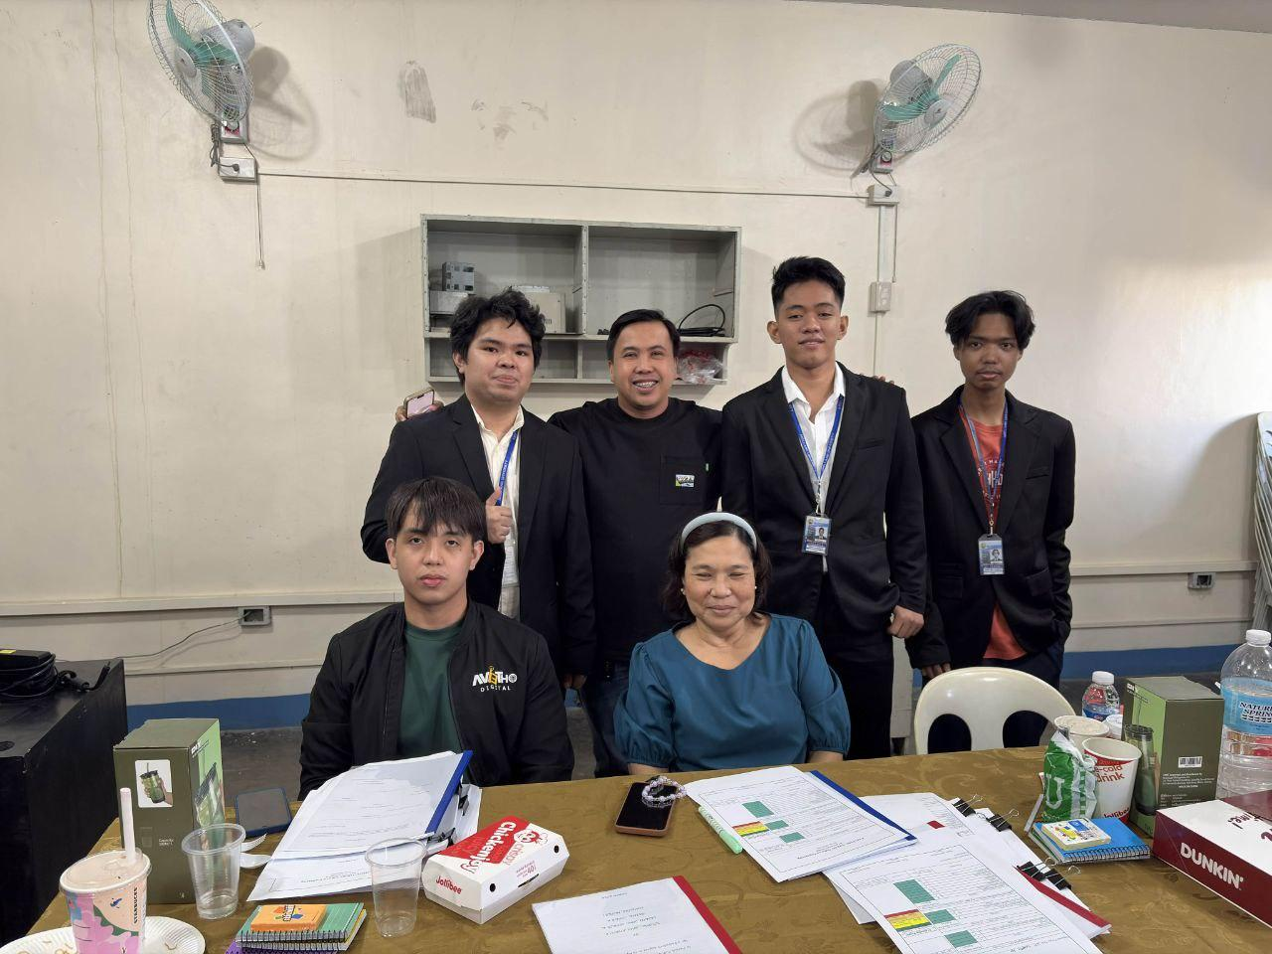
Figure 5: Final Defense with Panelists

